Parkstone Focused Reading Texts 2024 2025

FS2 | Autumn 1 | Autumn 2 | Spring 1 | Spring 2 | Summer 1 | Summer 2
Reading text: one text per week used for story time and focused discussion | The Three Little Pigs  Goldilocks and the 3 bears  Little Red Riding Hood  Hairy Maclary  Not Now Bernard  Winnie the Witch  Pumpkin Soup | In every house on every street  Schools of the past, present and future (non-fiction)  Gorilla  The Mixed Up Chameleon  Katie Morag and the grand concert  Augustus and his smile | Fleabag  Cuddly Dudley  Poetry – When I grow up  Ridiculous  Mr Gumpy’s Motor Car | Katie Morag and the Two Grandmothers  Handa’s Surprise  Mr Bear’s Trumpet  Float  Camille and the Sunflower | The Best Birthday Present Ever!  Where the Wild Things Are  Somebody swallowed Stanley  The Wind Blew  Granny’s quilt  Foggy Foggy Forest | The Jolly Postman  The Carnival of the Animals  Childrens’ story choices
Y1 | Autumn 1 | Autumn 2 | Spring 1 | Spring 2 | Summer 1 | Summer 2
Reading/ Focused text | The Bog Baby  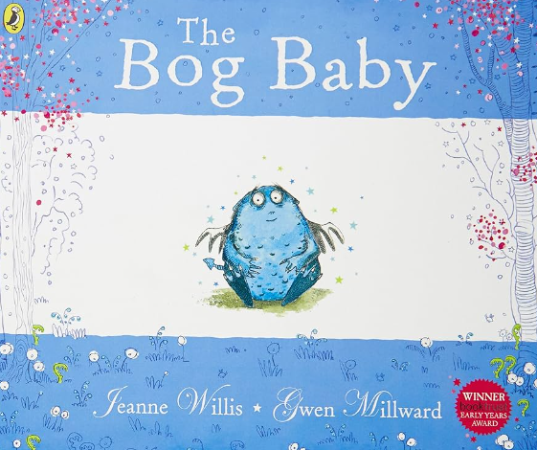 | Do Not Bring Your Dragon to the Library  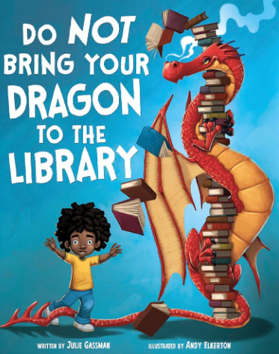 | The Tiny Seed  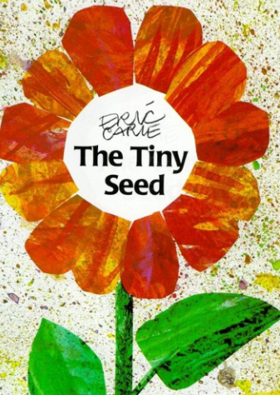 | Dogger  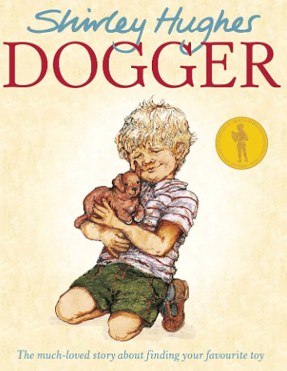 | The Lighthouse Keeper’s Lunch  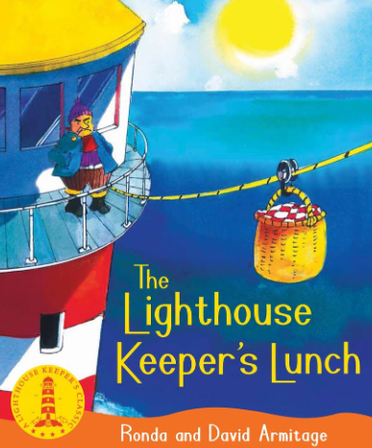 | Lost and Found  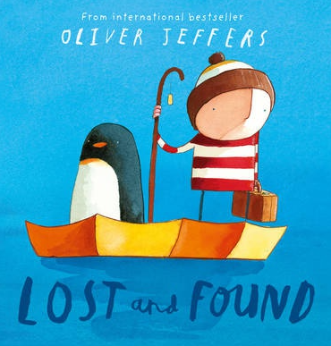
Y2 | Autumn 1 | Autumn 2 | Spring 1 | Spring 2 | Summer 1 | Summer 2
Reading text | The Day the Crayons Quit  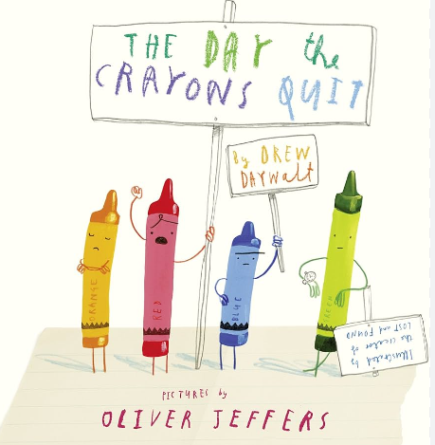 | Traction Man is Here  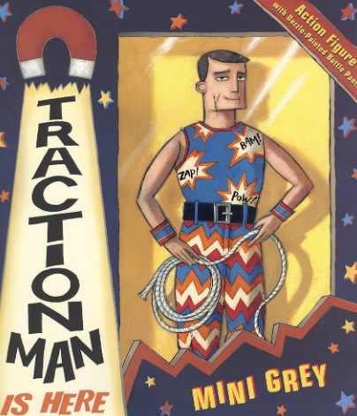 | Little Evie in the Wild Woods  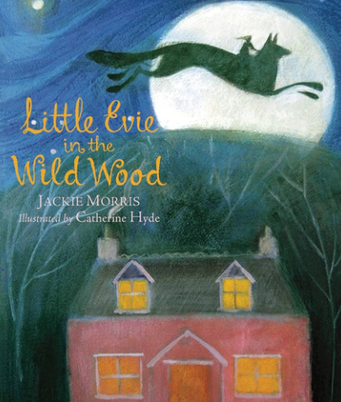 | Leon and the Place Between  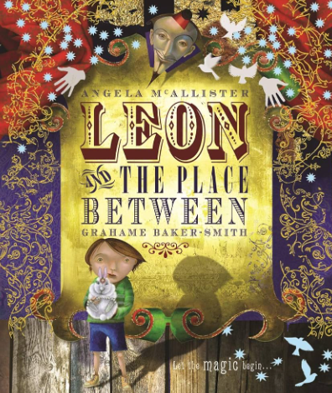 | Man on the Moon  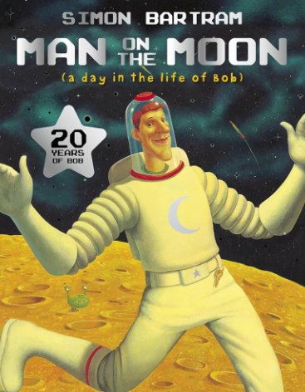 | 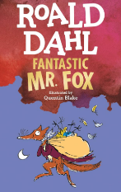  Fantastic Mr Fox
Y3 | Autumn 1 | Autumn 2 | Spring 1 | Spring 2 | Summer 1 | Summer 2
Reading text | The Owl who was Afraid of the Dark  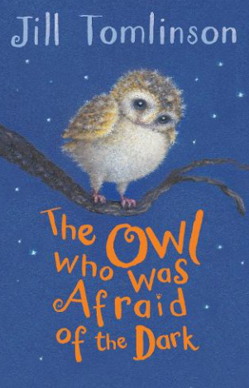 | Varjak Paw  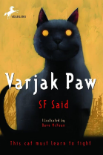 | The Firework-Maker’s Daughter  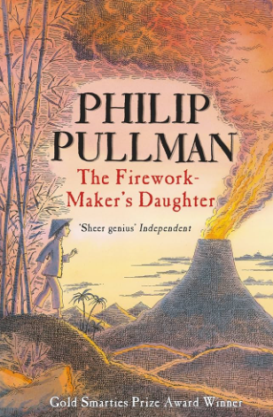 | Stitch Head  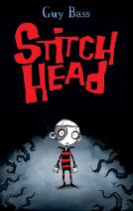 | Charlie and the Chocolate Factory  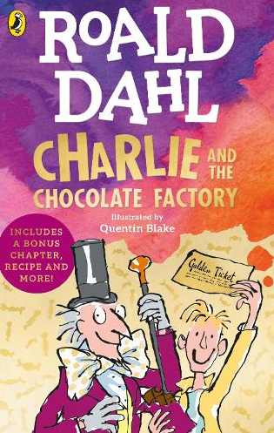 | The Astounding Broccoli Boy  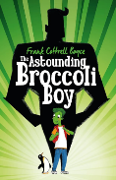
Y4 | Autumn 1 | Autumn 2 | Spring 1 | Spring 2 | Summer 1 | Summer 2
Reading text | Krindlekrax  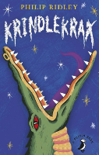 | Kid Normal  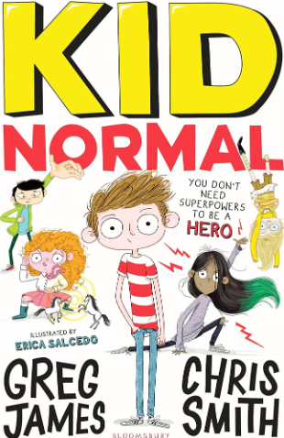 | The Land of Roar  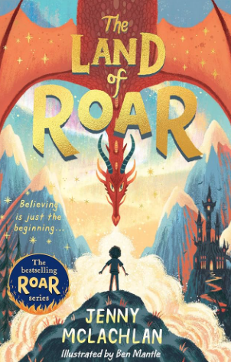 | Kensuke’s Kingdom  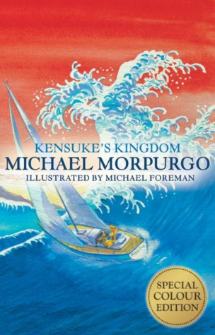 | The BFG  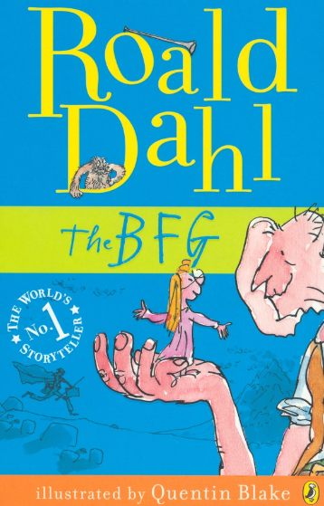 | How to Train your Dragon  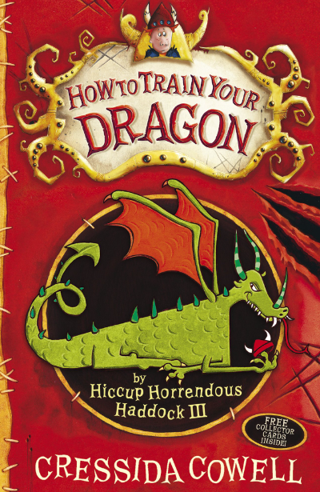
Y5 | Autumn 1 | Autumn 2 | Spring 1 | Spring 2 | Summer 1 | Summer 2
Reading text | Beowulf  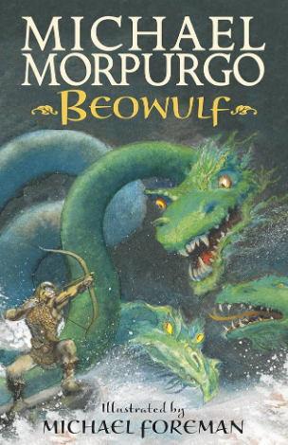 | The Storm Keeper’s Island  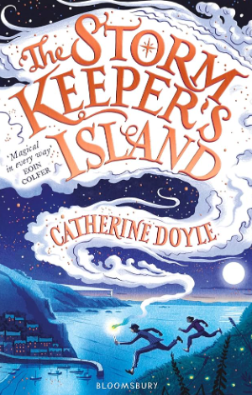 | Secrets of a Sun King  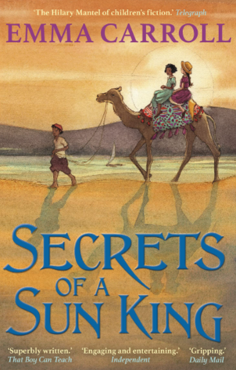 | Room 13  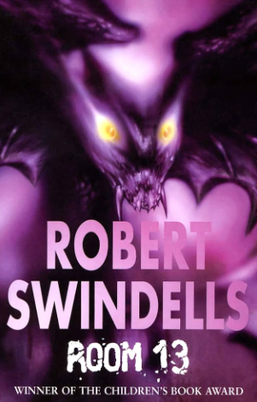 | Holes  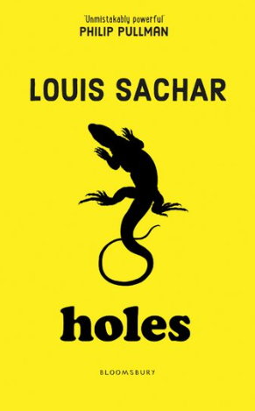 | The Nowhere Emporium  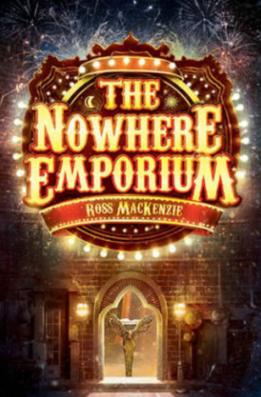
Y6 | Autumn 1 | Autumn 2 | Spring 1 | Spring 2 | Summer 1 | Summer 2
Reading text | Wild Boy  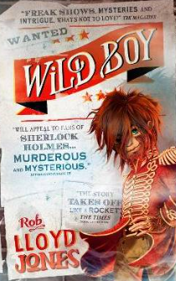 | Letters from the Lighthouse  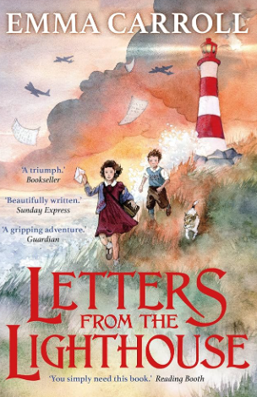 | The Ghouls of Howlfair  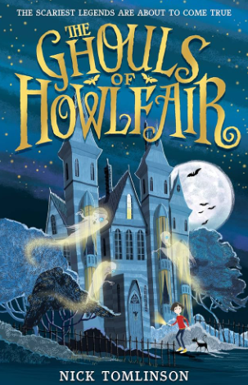 | The Girl of Ink and Stars  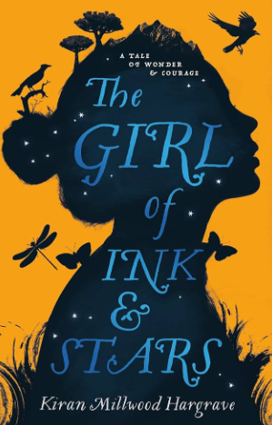 | The Giant’s Necklace  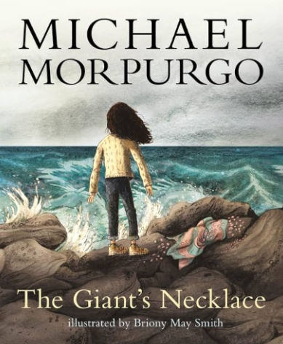 | Mortal Engines  