Parkstone Writing Long Term Plan (including the focused Reading text) 2024

FS2 | Autumn 1 | Autumn 2 | Spring 1 | Spring 2 | Summer 1 | Summer 2
Reading text: one text per week used for story time and focused discussion | The Three Little Pigs  Goldilocks and the 3 bears  Little Red Riding Hood  Hairy Maclary  Not Now Bernard  Winnie the Witch  Pumpkin Soup | In every house on every street  Schools of the past, present and future (non-fiction)  Gorilla  The Mixed Up Chameleon  Katie Morag and the grand concert  Augustus and his smile | Fleabag  Cuddly Dudley  Poetry – When I grow up  Ridiculous  Mr Gumpy’s Motor Car | Katie Morag and the Two Grandmothers  Handa’s Surprise  Mr Bear’s Trumpet  Float  Camille and the Sunflower | The Best Birthday Present Ever!  Where the Wild Things Are  Somebody swallowed Stanley  The Wind Blew  Granny’s quilt  Foggy Foggy Forest | The Jolly Postman  The Carnival of the Animals  Childrens’ story choices
Y1 | Autumn 1 | Autumn 2 | Spring 1 | Spring 2 | Summer 1 | Summer 2
Reading/ Focused text | The Bog Baby  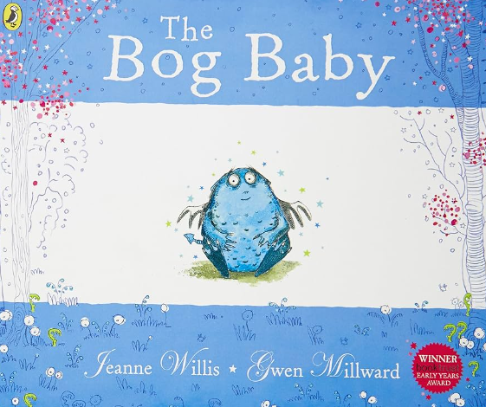 | Do Not Bring Your Dragon to the Library  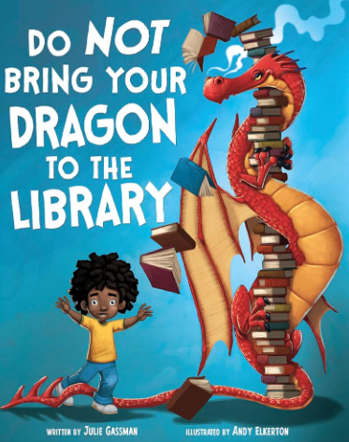 | The Tiny Seed  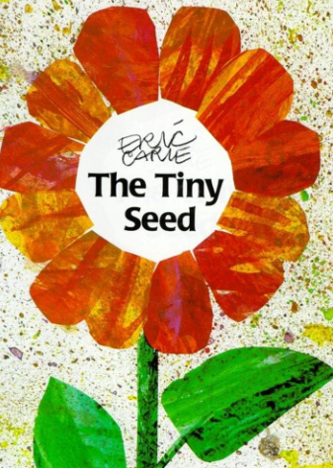 | Dogger  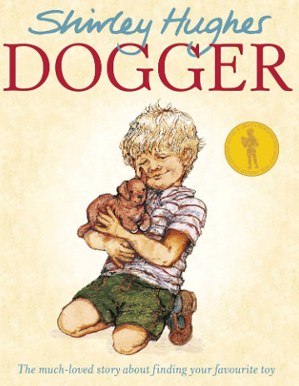 | The Lighthouse Keeper’s Lunch  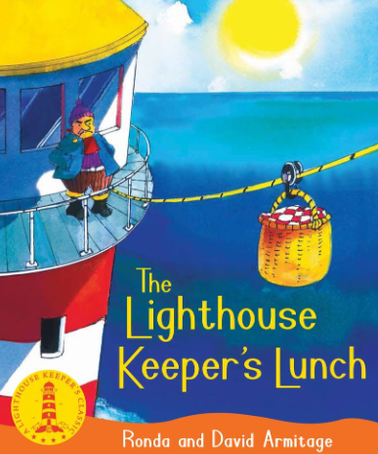 | Lost and Found  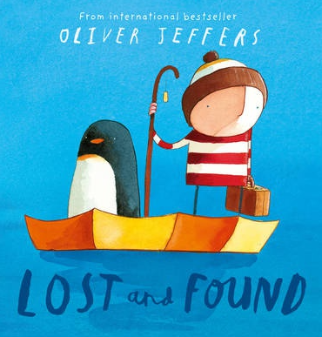
 | Narrative – character and setting description  Character toolkit  (2 weeks each) | Narrative – character and setting description  Setting toolkit  (2 weeks each) | Narrative – Journey Tale (retelling the story of the tiny seed)  Action Toolkit  (3 weeks) | Narrative – losing tale  Description toolkit  (3 weeks) | Narrative – wishing tale  Description toolkit  (3 weeks) | Narrative- journey tale  Action Toolkit  (3 weeks)
 | Non-narrative – Information  about Frogs  (2 weeks) | Non-narrative –  Instructions/ rules for different situations (school, library, break times etc)  (2 weeks) | Non-narrative – Instructions  How to plant a seed  (2 weeks) | Non-narrative – Recount Text  (3 weeks) | Non-narrative – Information Text  (3 weeks) | Non-narrative – Recount Text  (3 weeks)
 | Creative writing  (2 weeks) | Creative writing  (2 weeks) | Creative writing | Creative writing | Creative writing  (1 week) | Creative writing  (1 week)
Y2 | Autumn 1 | Autumn 2 | Spring 1 | Spring 2 | Summer 1 | Summer 2
Reading text | The Day the Crayons Quit  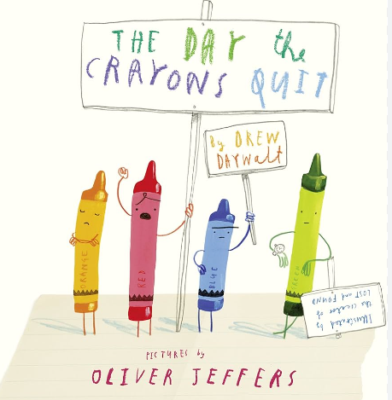 | Traction Man is Here  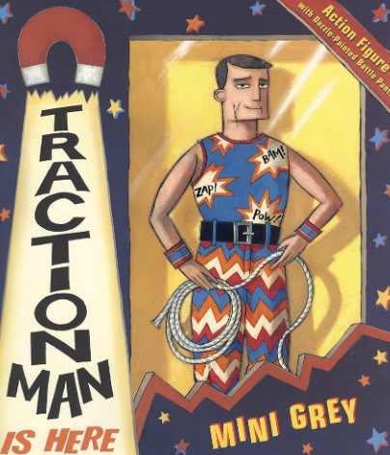 | Little Evie in the Wild Woods  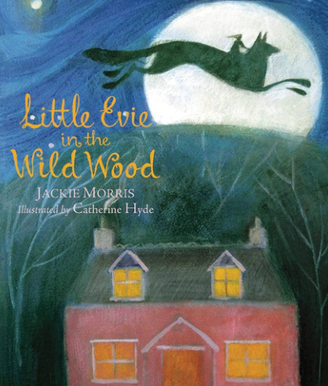 | Leon and the Place Between  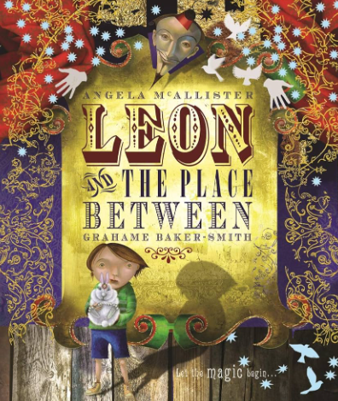 | Man on the Moon  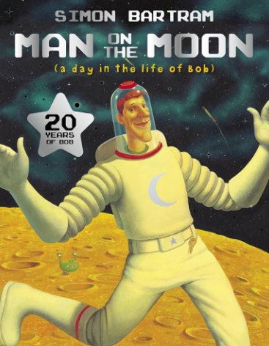 | 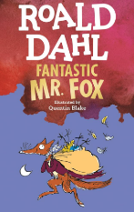  Fantastic Mr Fox
 | Narrative – character description and setting description based on The Tunnel  Setting and Character Toolkits  (2 weeks each) | Narrative – Character description and setting description  Setting and Character Toolkits  (2 weeks each) | Narrative – Warning tale  Little Red Riding Hood  Suspense Toolkit  (3 weeks) | Narrative – Wishing Tale  Lila and the Secret of Rain  Dialogue Toolkit  (3 weeks) | Narrative – Conquering the Monster tale  Jack and the Beanstalk  Action Toolkit  (3weeks) | Narrative – Journey Tale  Man on the Moon  Description Toolkit  (3weeks)
 | Non-narrative – recount/biography of Amy Johnson  (Link to History cycle A and Cycle B = Neil Armstrong)  (2 weeks) | Non- Narrative  Instructions -  How to Wash the Dishes  (2 weeks) | Non- Narrative – Information Text about trees  (3 weeks) | Non-narrative – Information Text  African Animals  (3 weeks) | Non-Narrative – Instructions  How to grow beans  (2 weeks) | Non-narrative -  Recount of visit to East Park  (3 weeks)
 | Creative writing  (2 weeks) | Creative Writing  (2 weeks) | Creative writing | Creative writing | Creative writing  (1 week) | Creative writing  (1 week)
Y3 | Autumn 1 | Autumn 2 | Spring 1 | Spring 2 | Summer 1 | Summer 2
Reading text | The Owl who was Afraid of the Dark  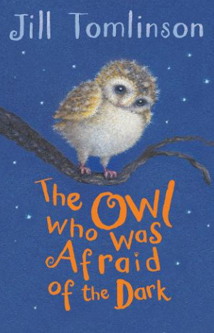 | Varjak Paw  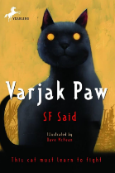 | The Firework-Maker’s Daughter  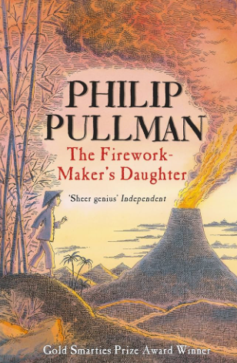 | Stitch Head  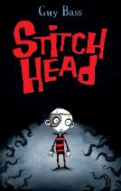 | Charlie and the Chocolate Factory  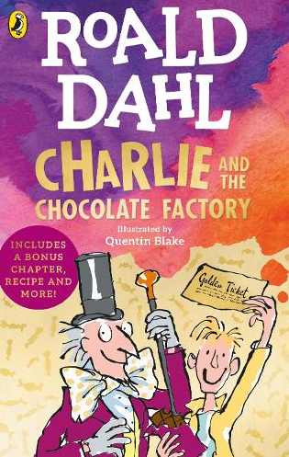 | The Astounding Broccoli Boy  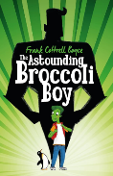
 | Narrative – Tale of Fear  Orion and the Dark  Settings Toolkit  (3 weeks) | Narrative – Portal Story  Leon  Dialogue Toolkit  (3 weeks) | Narrative – quest story  The Stone Trolls  Action Toolkit  (3 weeks) | Narrative – Warning Tale  Staying Out  Description Toolkit  (3 weeks) | Narrative – Rags to Riches Tale  Cinderella  Character Toolkit  (3 weeks) | Narrative – Conquering the Monster Tale  Adventure at Sandy Cove  Suspense Toolkit  (3 weeks)
 | Non-narrative –  Information Text  All about Owls  (3 weeks) | Non-narrative – Instructions  How to catch a Dragon (mythical Greek beast)  (3 weeks) | Non-narrative – Recount Text based on a real event (special day at school or visitor)  (3 weeks) | Non-narrative – Information Text  Roman Gladiators  (3 weeks) | Non-narrative – Persuasive letter for Wildlife Area (or similar)  (3 weeks) | Non-narrative – Recount of trip  (3 weeks)
 | Creative writing  (2 weeks) | Creative writing  (2 weeks) | Creative writing | Creative writing | Creative writing  (1 week) | Creative writing  (1 week)
Y4 | Autumn 1 | Autumn 2 | Spring 1 | Spring 2 | Summer 1 | Summer 2
Reading text | Krindlekrax  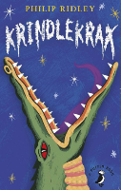 | Kid Normal  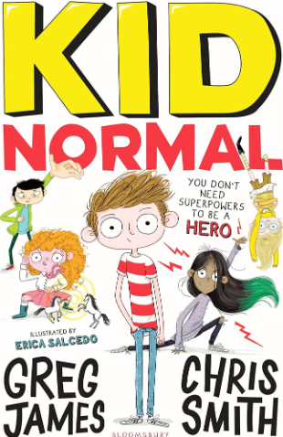 | The Land of Roar  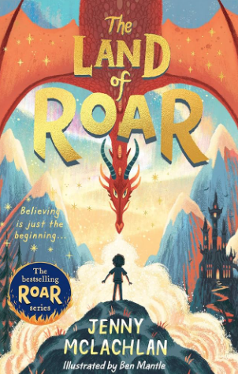 | Kensuke’s Kingdom  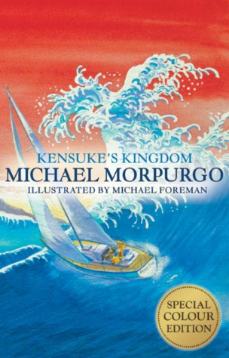 | The BFG  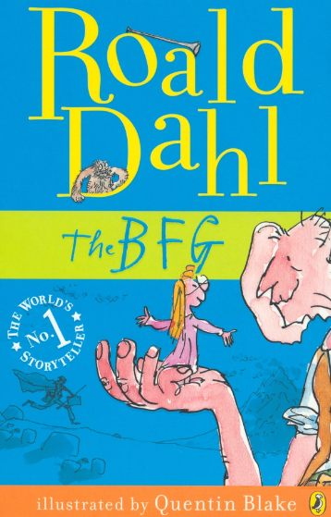 | How to Train your Dragon  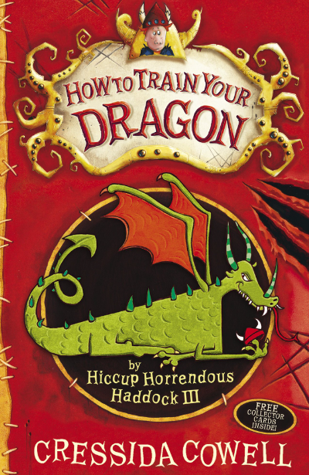
 | Narrative – Conquering the Monster Tale  The Swamp Elixir  Description toolkit  (3 weeks) | Narrative – Wishing Tale  King Midas and the Golden touch  Dialogue Toolkit | Narrative – Portal Tale  Elf Road  Settings Toolkit  (3 weeks) | Narrative – Tale of Fear  Alien Invasion  Suspense Toolkit  (3 weeks) | Narrative – Warning Tale  The Old Warehouse  Character Toolkit  (3 weeks) | Narrative- Tale  Smaug  Action and Opening/Endings Toolkits  (3 weeks)
 | Non-narrative – Discussion text.  Do we still need Zoos?  (3 weeks) | Instructions  How to Slay the Minotaur - Instructions  (3 weeks) | Non-narrative – Persuasive Text  Join Boudicca’s Army  (3 weeks) | Non-narrative – Newspaper report (recount text)  Boy Overboard! Or Boy Rescued! Linked to Kensuke’s Kingdom  (3 weeks) | Non-narrative – Explanation Text  How does the digestive System Work?  (3 weeks) | Information Text  Life as an Anglo Saxon  (3 weeks)
 | Creative writing  (2 weeks) | Creative writing  (2 weeks) | Creative writing | Creative writing | Creative writing  (1 week) | Creative writing  (1 week)
Y5 | Autumn 1 | Autumn 2 | Spring 1 | Spring 2 | Summer 1 | Summer 2
Reading text | Beowulf  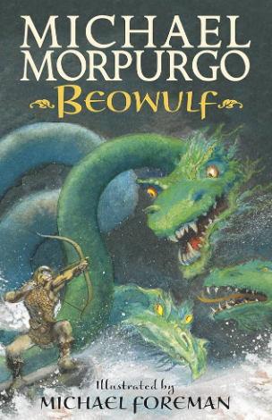 | The Storm Keeper’s Island  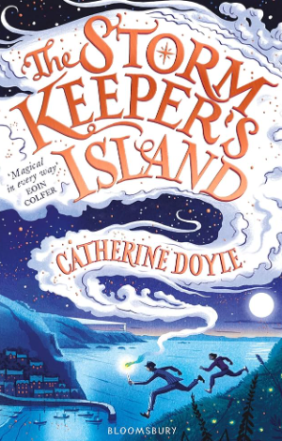 | Secrets of a Sun King  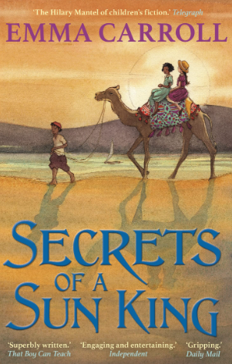 | Room 13  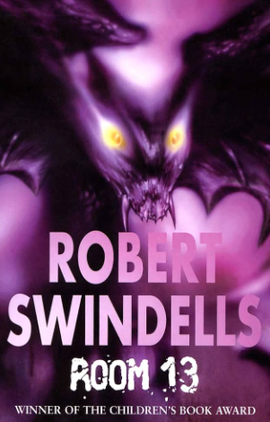 | Holes  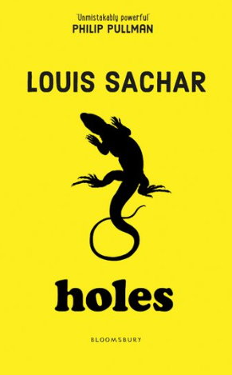 | The Nowhere Emporium  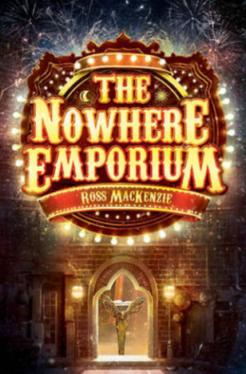
 | Narrative-  Over-coming the monster story  Description toolkit  (3 weeks) | Narrative -  A Close Encounter  Suspense Toolkit  (3 weeks) | Narrative – Portal Story  Time-slip Scarab  Settings Toolkit | Narrative – character flaw story  The Secret Garden  Character Toolkit  (3 weeks) | Narrative – Rags to Riches Tale  The Street Child  Action and Openings and endings Toolkits  (3 weeks) | Narrative - Fantasy story  Character and dialogue toolkits  (3 weeks)
 | Non-narrative – Information  (3 weeks) | Non-narrative – Instructions  (3 weeks) | Non-narrative –  Explanation Text  (3 weeks) | Non-narrative - Persuasive  Visit Hull (Visit Whitby model text linked to Room 13)  (3 weeks) | Non-narrative – Discussion Text  Should Jim Jarvis have escaped the workhouse?  (3 weeks) | Non-narrative – Recount Text  Diary recount of the appearance of the Nowhere Emporium  (3 weeks)
 | Creative writing  (2 weeks) | Creative writing  (2 weeks) | Creative writing | Creative writing | Creative writing  (1 week) | Creative writing  (1 week)
Y6 | Autumn 1 | Autumn 2 | Spring 1 | Spring 2 | Summer 1 | Summer 2
Reading text | Wild Boy  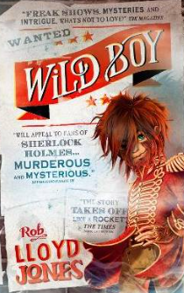 | Letters from the Lighthouse  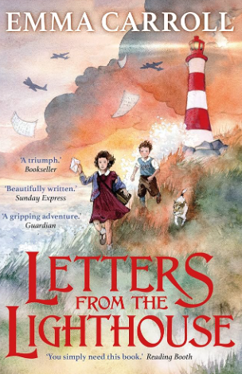 | The Ghouls of Howlfair  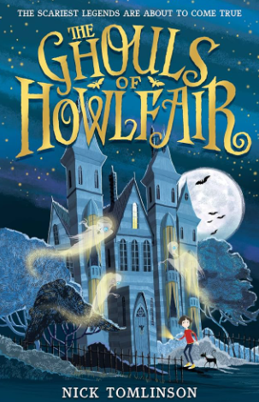 | The Girl of Ink and Stars  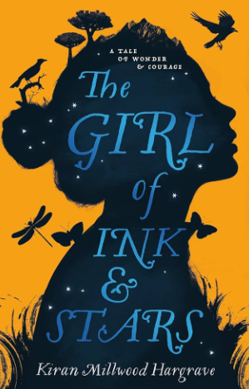 | The Giant’s Necklace  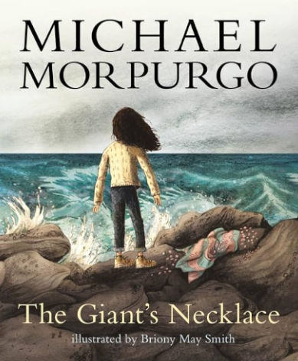 | Mortal Engines  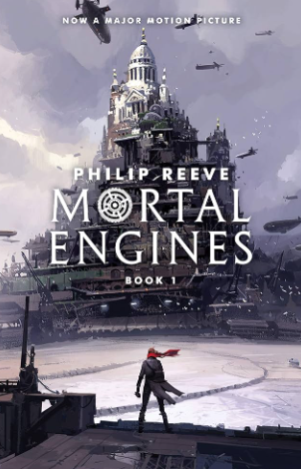
 | Narrative – Tale  Little Freak (story based on the Film)  Description Toolkit  (3 weeks) | Narrative - Finding/portal story  The Gas Mask  Character & dialogue toolkit  (3 weeks) | Narrative - quest story  Kidnapped  Suspense toolkit  (3 weeks) | Narrative – warning story  Keep off the Tracks  Action Toolkit  (3 weeks) | Narrative – Wishing Tale  Cherry’s Story  Setting Toolkit  (3 weeks) | Narrative –  Alma  Opening and endings Toolkit  (3 weeks)
 | Non-narrative – Balanced argument  Should Freakshows have been a form of entertainment? (3 weeks) | Non-narrative – Explanation Text  Why were children evacuated in WW2?  (3 weeks) | Non-narrative – Information and Recount Text  Biography (link to Science)  Charles Darwin cycle A and Neil Armstrong or Isaac Newton cycle B  (3 weeks) | Non-narrative – Newspaper report (recount)  (3 weeks) | Non-narrative – Discussion Text  Should Cherry be allowed to stay on the beach alone?  (3 weeks) | Non-narrative – Persuasive letter about end of year school trip  (2 weeks)
 | Creative writing  (2 weeks) | Creative writing  (2 weeks) | Creative writing | Creative writing | Creative writing  (1 week) | Creative writing  (1 week)

