
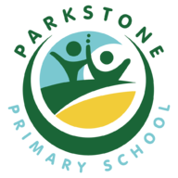
Parkstone Primary School
Design and Technology Long Term Plan

Cycle A
 | Autumn | Spring | Summer
 | Construction | Food Technology (except EYFS) | Textiles
EYFS | To name and use one handed tools safely | To be able to connect different materials in a variety of ways and for different reasons | To weave and lace up different materials
Y1/2 | A moving storyboard | A salad with a topping | A hand puppet
Y3/4 | A moving toy | A batch of cookies | A holder/purse/wallet (with a button fastening)
Y5/6 | An electronic nightlight (Crumble Kit) | A springtime minestrone | A sunhat/bucket hat (Use CAD)

Cycle B

 | Autumn | Spring | Summer
 | Construction | Food Technology (except EYFS) | Textiles
EYFS | To name and use one handed tools safely | To be able to connect different materials in a variety of ways and for different reasons | To weave and lace up different materials
Y1/2 | A free-standing structure | A fruit salad | A pouch
Y3/4 | A moving Christmas card | A bread-based product | A patchwork handkerchief
Y5/6 | A toy vehicle | A yeast-based product | A tote bag (with front pocket and button)

