Year 3 Reading Medium Term Plan
Autumn 1 – The Owl who was Afraid of the Dark (Jill Tomlinson)
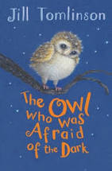
Skills | Objectives  (Word Reading) | What should be seen in the classroom?
Phonics and decoding | To use phonic knowledge to decode quickly and accurately (may still need support to read longer unknown words).  To apply knowledge of root words and prefixes, including in-, im-, il-, ir-, dis-, mis-, un-, re-, sub-, inter-, super-, anti- and auto- to begin to read aloud.*  To apply knowledge of root words and suffixes/word endings, including -ation,-ly, -ous, -ture, -sure, -sion,-tion, -ssion and -cian, to begin to read aloud.*  To apply knowledge of root words to read aloud and to understand the meaning of unfamiliar words.  * These are detailed in the word lists within the spelling appendix to the national curriculum (English Appendix 1). Teachers should refer to these to exemplify the words that pupils should be able to read as well as spell | - Phonics teaching, to the children who did not pass the re-take in Y2 of Phonics screening  - Differentiated groups for Guided Reading, whereby any child below their reading age is having intervention, and where children above expected are being moved on. Book banded books (including non-fiction) used to maintain word reading skills and for teacher to promote basic comprehension skills.  - Word Walls recording key vocabulary that has been clarified and needs to ‘stick’  - Daily individual reading if required
Common Exception Words/ HFW | To read Y3/4 common exception words.
Fluency | I can read aloud and independently.
Skills | Objectives | What should be seen in the classroom?
Understanding and correcting inaccuracies | To check that the text makes sense to them, discussing their understanding and explaining the meaning of words in context.  To ask questions to improve their understanding of a text. | - Daily individual reading for some  - Daily story time  - Use of Bug Club (for fluency and/or mastery sessions)  - Twice weekly fluency sessions (banded books including non-fiction/mastery text focusing on word reading skills)  - 3 Whole class Reading Mastery lessons per week, with teachers working with a focus group to develop skills  - Teacher supporting Core Text with supplementary texts to provide opportunities to compare and contrast where possible.  - Working Walls recording key discussion points and sentence stems  - Think Aloud approach – ‘It makes me think that…’ ‘When I look at this image, I see…’ ‘When I read that sentence/word, I imagine…’  - Retelling of stories/poems orally and performances of plays they have read
Connecting and becoming familiar with texts | To increase their familiarity with a wide range of books, including fairy stories, myths and legends, and retelling some of these orally  To identify themes and conventions in a wide range of books  To listen to and discussing a wide range of fiction, poetry, plays, non-fiction and reference books or textbooks  To read books that are structured in different ways and reading for a range of purposes.  To participate in discussion about both books that are read to them and those they can read for themselves, taking turns and listening to what others say.
Non Fiction | To retrieve and record information from non-fiction texts.
Poetry and Performance | To prepare poems and play scripts to read aloud and to perform, showing understanding through intonation, tone, volume and action.  To recognise some different forms of poetry.
Skills  (focused task in books) | Comprehension (VIPERS)  In books:  - One task in books based on applying skill being taught  - One independent task in books applying VIPERS skills | Question Stems  (Task examples for books)
Week 1  Vocabulary | To use dictionaries to check the meaning of words that they have read. | • What do the words ...... and ...... suggest about the character, setting and mood?  • Which word tells you that....?  • Which keyword tells you about the character/setting/mood?  • Find one word in the text which means......  • Find and highlight the word that is closest in meaning to.......  • Find a word or phrase which shows/suggests that.......
Week 2  Inference | To draw inferences, such as inferring a character’s feelings, thoughts and motives from their actions. | Find and copy a group of words which show that...  • How do these words make the reader feel? How does this paragraph suggest this?  • How do the descriptions of ...... show that they are ........ ?  • How can you tell that...... ?  • What impression of ...... do you get from these paragraphs?  • What voice might these characters use?  • What was .... thinking when..... ?  • Who is telling the story?
Week 3  Prediction | To justify predictions using evidence from the text. | • From the cover what do you think this text is going to be about?  • What is happening now? What happened before this? What will happen after?  • What does this paragraph suggest will happen next? What makes you think this?  • Do you think the choice of setting will influence how the plot develops?  • Do you think... will happen? Yes, no or maybe? Explain your answer using evidence from the text.
Week 4  Explanation | To discuss words and phrases that capture the reader’s interest and imagination. | • Why is the text arranged in this way?  • What structures has the author used?  • What is the purpose of this text feature?  • Is the use of ..... effective?  • The mood of the character changes throughout the text. Find and copy the phrases which show this.  • What is the author’s point of view?  • What effect does ..... have on the audience?  • How does the author engage the reader here?  • Which words and phrases did ..... effectively?  • Which section was the most interesting/exciting part?  • How are these sections linked?
Week 5  Retrieval | To retrieve and record information from a fiction text. | How would you describe this story/text? What genre is it? How do you know?  • How did...? How often...? Who had...? Who is...? Who did....?  • What happened to...?  • What does.... do?  • How ..... is ........?  • What can you learn about ...... from this section?  • Give one example of......  • The story is told from whose perspective?
Week 6  Sequence/summarise | To summarise the main ideas from a specific paragraph. | • Can you number these events 1-5 in the order that they happened?  • What happened after .......?  • What was the first thing that happened in the story?  • Can you summarise in a sentence the opening/middle/end of the story?  • In what order do these chapters occur in the story?

Year 3 Reading Medium Term Plan
Autumn 1 – Stig of the Dump (Clive King)
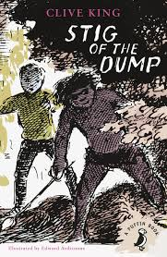

Skills | Objectives  (Word Reading) | What should be seen in the classroom?
Phonics and decoding | To use phonic knowledge to decode quickly and accurately (may still need support to read longer unknown words).  To apply knowledge of root words and prefixes, including in-, im-, il-, ir-, dis-, mis-, un-, re-, sub-, inter-, super-, anti- and auto- to begin to read aloud.*  To apply knowledge of root words and suffixes/word endings, including -ation,-ly, -ous, -ture, -sure, -sion,-tion, -ssion and -cian, to begin to read aloud.*  To apply knowledge of root words to read aloud and to understand the meaning of unfamiliar words.  * These are detailed in the word lists within the spelling appendix to the national curriculum (English Appendix 1). Teachers should refer to these to exemplify the words that pupils should be able to read as well as spell | - Phonics teaching, to the children who did not pass the re-take in Y2 of Phonics screening  - Differentiated groups for Guided Reading, whereby any child below their reading age is having intervention, and where children above expected are being moved on. Book banded books (including non-fiction) used to maintain word reading skills and for teacher to promote basic comprehension skills.  - Word Walls recording key vocabulary that has been clarified and needs to ‘stick’  - Daily individual reading if required
Common Exception Words/ HFW | To read Y3/4 common exception words.
Fluency | I can read aloud and independently.

Skills | Objectives | What should be seen in the classroom?
Understanding and correcting inaccuracies | To check that the text makes sense to them, discussing their understanding and explaining the meaning of words in context.  To ask questions to improve their understanding of a text. | - Daily individual reading for some  - Daily story time  - Use of Bug Club (for fluency and/or mastery sessions)  - Twice weekly fluency sessions (banded books including non-fiction/mastery text focusing on word reading skills)  - 3 Whole class Reading Mastery lessons per week, with teachers working with a focus group to develop skills  - Teacher supporting Core Text with supplementary texts to provide opportunities to compare and contrast where possible.  - Working Walls recording key discussion points and sentence stems  - Think Aloud approach – ‘It makes me think that…’ ‘When I look at this image, I see…’ ‘When I read that sentence/word, I imagine…’  - Retelling of stories/poems orally and performances of plays they have read
Connecting and becoming familiar with texts | To increase their familiarity with a wide range of books, including fairy stories, myths and legends, and retelling some of these orally  To identify themes and conventions in a wide range of books  To listen to and discussing a wide range of fiction, poetry, plays, non-fiction and reference books or textbooks  To read books that are structured in different ways and reading for a range of purposes.  To participate in discussion about both books that are read to them and those they can read for themselves, taking turns and listening to what others say.
Non Fiction | To retrieve and record information from non-fiction texts.
Poetry and Performance | To prepare poems and play scripts to read aloud and to perform, showing understanding through intonation, tone, volume and action.  To recognise some different forms of poetry.
Skills  (focused task in books) | Comprehension (VIPERS)  In books:  - One task in books based on applying skill being taught  - One independent task in books applying VIPERS skills | Question Stems  (Task examples for books)
Week 1  Vocabulary | To use dictionaries to check the meaning of words that they have read. | • What do the words ...... and ...... suggest about the character, setting and mood?  • Which word tells you that....?  • Which keyword tells you about the character/setting/mood?  • Find one word in the text which means......  • Find and highlight the word that is closest in meaning to.......  • Find a word or phrase which shows/suggests that.......
Week 2  Inference | To draw inferences, such as inferring a character’s feelings, thoughts and motives from their actions. | Find and copy a group of words which show that...  • How do these words make the reader feel? How does this paragraph suggest this?  • How do the descriptions of ...... show that they are ........ ?  • How can you tell that...... ?  • What impression of ...... do you get from these paragraphs?  • What voice might these characters use?  • What was .... thinking when..... ?  • Who is telling the story?
Week 3  Prediction | To justify predictions using evidence from the text. | • From the cover what do you think this text is going to be about?  • What is happening now? What happened before this? What will happen after?  • What does this paragraph suggest will happen next? What makes you think this?  • Do you think the choice of setting will influence how the plot develops?  • Do you think... will happen? Yes, no or maybe? Explain your answer using evidence from the text.
Week 4  Explanation | To discuss words and phrases that capture the reader’s interest and imagination. | • Why is the text arranged in this way?  • What structures has the author used?  • What is the purpose of this text feature?  • Is the use of ..... effective?  • The mood of the character changes throughout the text. Find and copy the phrases which show this.  • What is the author’s point of view?  • What effect does ..... have on the audience?  • How does the author engage the reader here?  • Which words and phrases did ..... effectively?  • Which section was the most interesting/exciting part?  • How are these sections linked?
Week 5  Retrieval | To retrieve and record information from a fiction text. | How would you describe this story/text? What genre is it? How do you know?  • How did...? How often...? Who had...? Who is...? Who did....?  • What happened to...?  • What does.... do?  • How ..... is ........?  • What can you learn about ...... from this section?  • Give one example of......  • The story is told from whose perspective?
Week 6  Sequence/summarise | To summarise the main ideas from a specific paragraph. | • Can you number these events 1-5 in the order that they happened?  • What happened after .......?  • What was the first thing that happened in the story?  • Can you summarise in a sentence the opening/middle/end of the story?  • In what order do these chapters occur in the story?

Year 3 Reading Medium Term Plan
Spring 1 – The Egyptian Cinderella (Shirley Climo)
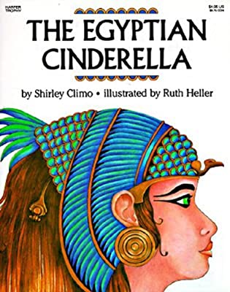
Skills | Objectives  (Word Reading) | What should be seen in the classroom?
Phonics and decoding | To use their phonic knowledge to decode quickly and accurately (may still need support to read longer unknown words).  To apply their growing knowledge of root words and prefixes, including in-, im-, il-, ir-, dis-, mis-, un-, re-, sub-, inter-, super-, anti- and auto- to begin to read aloud.*  To apply their growing knowledge of root words and suffixes/word endings, including -ation,-ly, -ous, -ture, -sure, -sion,-tion, -ssion and -cian, to begin to read aloud.*  To apply knowledge of root words to read aloud and to understand the meaning of unfamiliar words.  * These are detailed in the word lists within the spelling appendix to the national curriculum (English Appendix 1). Teachers should refer to these to exemplify the words that pupils should be able to read as well as spell | - Phonics teaching, to the children who did not pass the re-take in Y2 of Phonics screening  - Differentiated groups for Guided Reading, whereby any child below their reading age is having intervention, and where children above expected are being moved on. Book banded books (including non-fiction) used to maintain word reading skills and for teacher to promote basic comprehension skills.  - Word Walls recording key vocabulary that has been clarified and needs to ‘stick’  - Daily individual reading if required
Common Exception Words/ HFW | To read Y3/4 common exception words.
Fluency | At this stage, teaching comprehension skills should be taking precedence over teaching word reading and fluency specifically. Any focus on word reading should support the development of vocabulary.

Skills | Objectives | What should be seen in the classroom?
Understanding and correcting inaccuracies | To check that the text makes sense to them, discussing their understanding and explaining the meaning of words in context.  To ask questions to improve their understanding of a text. | - Daily individual reading for some  - Daily story time  - Use of Bug Club (for fluency and/or mastery sessions)  - Twice weekly fluency sessions (banded books including non-fiction/mastery text focusing on word reading skills)  - 3 Whole class Reading Mastery lessons per week, with teachers working with a focus group to develop skills  - Teacher supporting Core Text with supplementary texts to provide opportunities to compare and contrast where possible.  - Working Walls recording key discussion points and sentence stems  - Think Aloud approach – ‘It makes me think that…’ ‘When I look at this image, I see…’ ‘When I read that sentence/word, I imagine…’  - Retelling of stories/poems orally and performances of plays they have read
Connecting and becoming familiar with texts | To increase their familiarity with a wide range of books, including fairy stories, myths and legends, and retelling some of these orally  To identify themes and conventions in a wide range of books  To listen to and discussing a wide range of fiction, poetry, plays, non-fiction and reference books or textbooks  To read books that are structured in different ways and reading for a range of purposes.  To participate in discussion about both books that are read to them and those they can read for themselves, taking turns and listening to what others say.
Non Fiction | To retrieve and record information from non-fiction texts.
Poetry and Performance | To prepare poems and play scripts to read aloud and to perform, showing understanding through intonation, tone, volume and action.  To recognise some different forms of poetry.
Skills  (focused task in books) | Comprehension (VIPERS)  In books:  - One task in books based on applying skill being taught  - One independent task in books applying VIPERS skills | Question Stems  (Task examples for books)
Week 1  Vocabulary | To use dictionaries to check the meaning of words that they have read.  To explain the meaning of words in context. | • What do the words ...... and ...... suggest about the character, setting and mood?  • Which word tells you that....?  • Which keyword tells you about the character/setting/mood?  • Find one word in the text which means......  • Find and highlight the word that is closest in meaning to.......  • Find a word or phrase which shows/suggests that.......
Week 2  Inference | To draw inferences, such as inferring a character’s feelings, thoughts and motives from their actions. | Find and copy a group of words which show that...  • How do these words make the reader feel? How does this paragraph suggest this?  • How do the descriptions of ...... show that they are ........ ?  • How can you tell that...... ?  • What impression of ...... do you get from these paragraphs?  • What voice might these characters use?  • What was .... thinking when..... ?  • Who is telling the story?
Week 3  Prediction | To justify predictions using evidence from the text. | • From the cover what do you think this text is going to be about?  • What is happening now? What happened before this? What will happen after?  • What does this paragraph suggest will happen next? What makes you think this?  • Do you think the choice of setting will influence how the plot develops?  • Do you think... will happen? Yes, no or maybe? Explain your answer using evidence from the text.
Week 4  Explanation | To discuss words and phrases that capture the reader’s interest and imagination.  To explain how language, structure, and presentation contribute to meaning. | • Why is the text arranged in this way?  • What structures has the author used?  • What is the purpose of this text feature?  • Is the use of ..... effective?  • The mood of the character changes throughout the text. Find and copy the phrases which show this.  • What is the author’s point of view?  • What effect does ..... have on the audience?  • How does the author engage the reader here?  • Which words and phrases did ..... effectively?  • Which section was the most interesting/exciting part?  • How are these sections linked?
Week 5  Retrieval | To retrieve and record information from a fiction text. | How would you describe this story/text? What genre is it? How do you know?  • How did...? How often...? Who had...? Who is...? Who did....?  • What happened to...?  • What does.... do?  • How ..... is ........?  • What can you learn about ...... from this section?  • Give one example of......  • The story is told from whose perspective?
Week 6  Sequence/summarise | To summarise the main ideas from a specific paragraph. | • Can you number these events 1-5 in the order that they happened?  • What happened after .......?  • What was the first thing that happened in the story?  • Can you summarise in a sentence the opening/middle/end of the story?  • In what order do these chapters occur in the story?

Year 3 Reading Medium Term Plan
Spring 1 – The Flower (John Light)
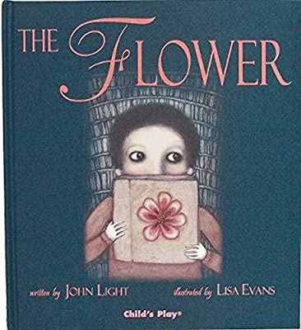
Skills | Objectives  (Word Reading) | What should be seen in the classroom?
Phonics and decoding | To use their phonic knowledge to decode quickly and accurately (may still need support to read longer unknown words).  To apply their growing knowledge of root words and prefixes, including in-, im-, il-, ir-, dis-, mis-, un-, re-, sub-, inter-, super-, anti- and auto- to begin to read aloud.*  To apply their growing knowledge of root words and suffixes/word endings, including -ation,-ly, -ous, -ture, -sure, -sion,-tion, -ssion and -cian, to begin to read aloud.*  To apply knowledge of root words to read aloud and to understand the meaning of unfamiliar words.  * These are detailed in the word lists within the spelling appendix to the national curriculum (English Appendix 1). Teachers should refer to these to exemplify the words that pupils should be able to read as well as spell | - Phonics teaching, to the children who did not pass the re-take in Y2 of Phonics screening  - Differentiated groups for Guided Reading, whereby any child below their reading age is having intervention, and where children above expected are being moved on. Book banded books (including non-fiction) used to maintain word reading skills and for teacher to promote basic comprehension skills.  - Word Walls recording key vocabulary that has been clarified and needs to ‘stick’  - Daily individual reading if required
Common Exception Words/ HFW | To read Y3/4 common exception words.
Fluency | At this stage, teaching comprehension skills should be taking precedence over teaching word reading and fluency specifically. Any focus on word reading should support the development of vocabulary.

Skills | Objectives | What should be seen in the classroom?
Understanding and correcting inaccuracies | To check that the text makes sense to them, discussing their understanding and explaining the meaning of words in context.  To ask questions to improve their understanding of a text. | - Daily individual reading for some  - Daily story time  - Use of Bug Club (for fluency and/or mastery sessions)  - Twice weekly fluency sessions (banded books including non-fiction/mastery text focusing on word reading skills)  - 3 Whole class Reading Mastery lessons per week, with teachers working with a focus group to develop skills  - Teacher supporting Core Text with supplementary texts to provide opportunities to compare and contrast where possible.  - Working Walls recording key discussion points and sentence stems  - Think Aloud approach – ‘It makes me think that…’ ‘When I look at this image, I see…’ ‘When I read that sentence/word, I imagine…’  - Retelling of stories/poems orally and performances of plays they have read
Connecting and becoming familiar with texts | To increase their familiarity with a wide range of books, including fairy stories, myths and legends, and retelling some of these orally  To identify themes and conventions in a wide range of books  To listen to and discussing a wide range of fiction, poetry, plays, non-fiction and reference books or textbooks  To read books that are structured in different ways and reading for a range of purposes.  To participate in discussion about both books that are read to them and those they can read for themselves, taking turns and listening to what others say.
Non Fiction | To retrieve and record information from non-fiction texts.
Poetry and Performance | To prepare poems and play scripts to read aloud and to perform, showing understanding through intonation, tone, volume and action.  To recognise some different forms of poetry.
Skills  (focused task in books) | Comprehension (VIPERS)  In books:  - One task in books based on applying skill being taught  - One independent task in books applying VIPERS skills | Question Stems  (Task examples for books)
Week 1  Vocabulary | To use dictionaries to check the meaning of words that they have read.  To explain the meaning of words in context. | • What do the words ...... and ...... suggest about the character, setting and mood?  • Which word tells you that....?  • Which keyword tells you about the character/setting/mood?  • Find one word in the text which means......  • Find and highlight the word that is closest in meaning to.......  • Find a word or phrase which shows/suggests that.......
Week 2  Inference | To draw inferences, such as inferring a character’s feelings, thoughts and motives from their actions. | Find and copy a group of words which show that...  • How do these words make the reader feel? How does this paragraph suggest this?  • How do the descriptions of ...... show that they are ........ ?  • How can you tell that...... ?  • What impression of ...... do you get from these paragraphs?  • What voice might these characters use?  • What was .... thinking when..... ?  • Who is telling the story?
Week 3  Prediction | To justify predictions using evidence from the text. | • From the cover what do you think this text is going to be about?  • What is happening now? What happened before this? What will happen after?  • What does this paragraph suggest will happen next? What makes you think this?  • Do you think the choice of setting will influence how the plot develops?  • Do you think... will happen? Yes, no or maybe? Explain your answer using evidence from the text.
Week 4  Explanation | To discuss words and phrases that capture the reader’s interest and imagination.  To explain how language, structure, and presentation contribute to meaning. | • Why is the text arranged in this way?  • What structures has the author used?  • What is the purpose of this text feature?  • Is the use of ..... effective?  • The mood of the character changes throughout the text. Find and copy the phrases which show this.  • What is the author’s point of view?  • What effect does ..... have on the audience?  • How does the author engage the reader here?  • Which words and phrases did ..... effectively?  • Which section was the most interesting/exciting part?  • How are these sections linked?
Week 5  Retrieval | To retrieve and record information from a fiction text. | How would you describe this story/text? What genre is it? How do you know?  • How did...? How often...? Who had...? Who is...? Who did....?  • What happened to...?  • What does.... do?  • How ..... is ........?  • What can you learn about ...... from this section?  • Give one example of......  • The story is told from whose perspective?
Week 6  Sequence/summarise | To summarise the main ideas from a specific paragraph. | • Can you number these events 1-5 in the order that they happened?  • What happened after .......?  • What was the first thing that happened in the story?  • Can you summarise in a sentence the opening/middle/end of the story?  • In what order do these chapters occur in the story?

Year 3 Reading Medium Term Plan
Summer 1 – The Great Kapok Tree (Lynne Cherry)
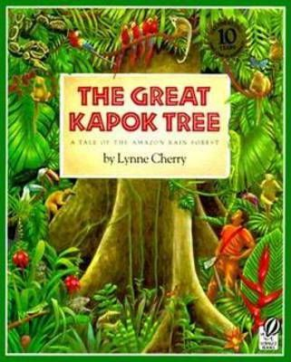
Skills | Objectives  (Word Reading) | What should be seen in the classroom?
Phonics and decoding | To use their phonic knowledge to decode quickly and accurately (may still need support to read longer unknown words).  To apply their growing knowledge of root words and prefixes, including in-, im-, il-, ir-, dis-, mis-, un-, re-, sub-, inter-, super-, anti- and auto- to begin to read aloud.*  To apply their growing knowledge of root words and suffixes/word endings, including -ation,-ly, -ous, -ture, -sure, -sion,-tion, -ssion and -cian, to begin to read aloud.*  To apply knowledge of root words to read aloud and to understand the meaning of unfamiliar words.  * These are detailed in the word lists within the spelling appendix to the national curriculum (English Appendix 1). Teachers should refer to these to exemplify the words that pupils should be able to read as well as spell | - Phonics teaching, to the children who did not pass the re-take in Y2 of Phonics screening  - Differentiated groups for Guided Reading, whereby any child below their reading age is having intervention, and where children above expected are being moved on. Book banded books (including non-fiction) used to maintain word reading skills and for teacher to promote basic comprehension skills.  - Word Walls recording key vocabulary that has been clarified and needs to ‘stick’  - Daily individual reading if required
Common Exception Words/ HFW | To read Y3/4 common exception words.
Fluency | At this stage, teaching comprehension skills should be taking precedence over teaching word reading and fluency specifically. Any focus on word reading should support the development of vocabulary.

Skills | Objectives | What should be seen in the classroom?
Understanding and correcting inaccuracies | To check that the text makes sense to them, discussing their understanding and explaining the meaning of words in context.  To ask questions to improve their understanding of a text. | - Daily individual reading for some  - Daily story time  - Use of Bug Club (for fluency and/or mastery sessions)  - Twice weekly fluency sessions (banded books including non-fiction/mastery text focusing on word reading skills)  - 3 Whole class Reading Mastery lessons per week, with teachers working with a focus group to develop skills  - Teacher supporting Core Text with supplementary texts to provide opportunities to compare and contrast where possible.  - Working Walls recording key discussion points and sentence stems  - Think Aloud approach – ‘It makes me think that…’ ‘When I look at this image, I see…’ ‘When I read that sentence/word, I imagine…’  - Retelling of stories/poems orally and performances of plays they have read
Connecting and becoming familiar with texts | To increase their familiarity with a wide range of books, including fairy stories, myths and legends, and retelling some of these orally  To identify themes and conventions in a wide range of books  To listen to and discussing a wide range of fiction, poetry, plays, non-fiction and reference books or textbooks  To read books that are structured in different ways and reading for a range of purposes.  To participate in discussion about both books that are read to them and those they can read for themselves, taking turns and listening to what others say.
Non Fiction | To retrieve and record information from non-fiction texts.
Poetry and Performance | To prepare poems and play scripts to read aloud and to perform, showing understanding through intonation, tone, volume and action.  To recognise some different forms of poetry.
Skills  (focused task in books) | Comprehension (VIPERS)  In books:  - One task in books based on applying skill being taught  - One independent task in books applying VIPERS skills | Question Stems  (Task examples for books)
Week 1  Vocabulary | To use dictionaries to check the meaning of words that they have read.  To explain the meaning of words in context. | • What do the words ...... and ...... suggest about the character, setting and mood?  • Which word tells you that....?  • Which keyword tells you about the character/setting/mood?  • Find one word in the text which means......  • Find and highlight the word that is closest in meaning to.......  • Find a word or phrase which shows/suggests that.......
Week 2  Inference | To draw inferences, such as inferring a character’s feelings, thoughts and motives from their actions. | Find and copy a group of words which show that...  • How do these words make the reader feel? How does this paragraph suggest this?  • How do the descriptions of ...... show that they are ........ ?  • How can you tell that...... ?  • What impression of ...... do you get from these paragraphs?  • What voice might these characters use?  • What was .... thinking when..... ?  • Who is telling the story?
Week 3  Prediction | To justify predictions using evidence from the text. | • From the cover what do you think this text is going to be about?  • What is happening now? What happened before this? What will happen after?  • What does this paragraph suggest will happen next? What makes you think this?  • Do you think the choice of setting will influence how the plot develops?  • Do you think... will happen? Yes, no or maybe? Explain your answer using evidence from the text.
Week 4  Explanation | To discuss words and phrases that capture the reader’s interest and imagination.  To explain how language, structure, and presentation contribute to meaning. | • Why is the text arranged in this way?  • What structures has the author used?  • What is the purpose of this text feature?  • Is the use of ..... effective?  • The mood of the character changes throughout the text. Find and copy the phrases which show this.  • What is the author’s point of view?  • What effect does ..... have on the audience?  • How does the author engage the reader here?  • Which words and phrases did ..... effectively?  • Which section was the most interesting/exciting part?  • How are these sections linked?
Week 5  Retrieval | To retrieve and record information from a fiction text. | How would you describe this story/text? What genre is it? How do you know?  • How did...? How often...? Who had...? Who is...? Who did....?  • What happened to...?  • What does.... do?  • How ..... is ........?  • What can you learn about ...... from this section?  • Give one example of......  • The story is told from whose perspective?
Week 6  Sequence/summarise | To summarise the main ideas from a specific paragraph. | • Can you number these events 1-5 in the order that they happened?  • What happened after .......?  • What was the first thing that happened in the story?  • Can you summarise in a sentence the opening/middle/end of the story?  • In what order do these chapters occur in the story?

Year 3 Reading Medium Term Plan
Summer 2 – The Firework Maker’s Daughter (Phillip Pullman)
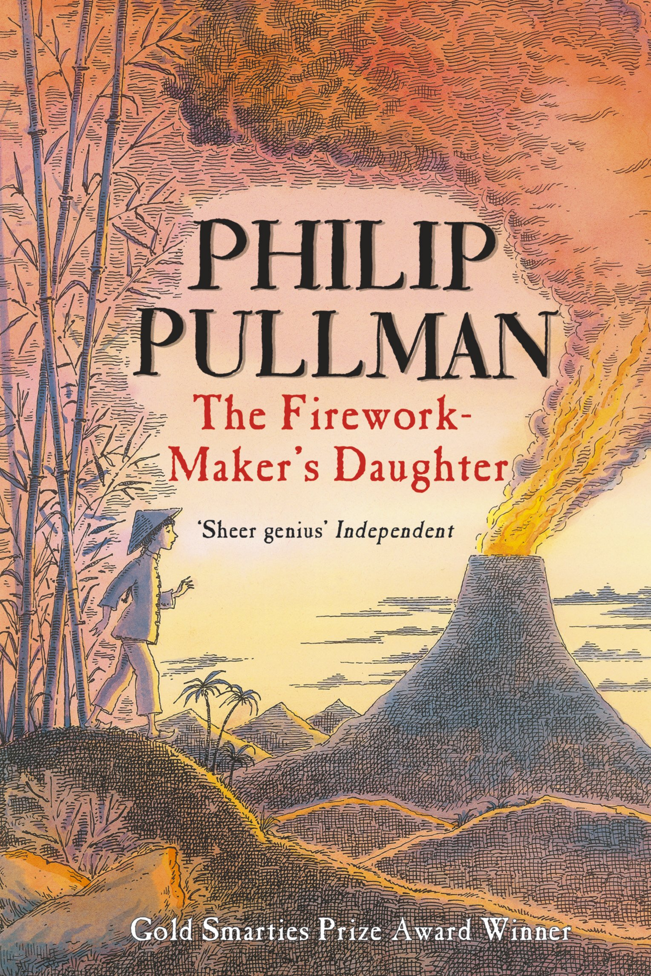
Skills | Objectives  (Word Reading) | What should be seen in the classroom?
Phonics and decoding | To use their phonic knowledge to decode quickly and accurately (may still need support to read longer unknown words).  To apply their growing knowledge of root words and prefixes, including in-, im-, il-, ir-, dis-, mis-, un-, re-, sub-, inter-, super-, anti- and auto- to begin to read aloud.*  To apply their growing knowledge of root words and suffixes/word endings, including -ation,-ly, -ous, -ture, -sure, -sion,-tion, -ssion and -cian, to begin to read aloud.*  To apply knowledge of root words to read aloud and to understand the meaning of unfamiliar words.  * These are detailed in the word lists within the spelling appendix to the national curriculum (English Appendix 1). Teachers should refer to these to exemplify the words that pupils should be able to read as well as spell | - Phonics teaching, to the children who did not pass the re-take in Y2 of Phonics screening  - Differentiated groups for Guided Reading, whereby any child below their reading age is having intervention, and where children above expected are being moved on. Book banded books (including non-fiction) used to maintain word reading skills and for teacher to promote basic comprehension skills.  - Word Walls recording key vocabulary that has been clarified and needs to ‘stick’  - Daily individual reading if required
Common Exception Words/ HFW | To read Y3/4 common exception words.
Fluency | At this stage, teaching comprehension skills should be taking precedence over teaching word reading and fluency specifically. Any focus on word reading should support the development of vocabulary.

Skills | Objectives | What should be seen in the classroom?
Understanding and correcting inaccuracies | To check that the text makes sense to them, discussing their understanding and explaining the meaning of words in context.  To ask questions to improve their understanding of a text. | - Daily individual reading for some  - Daily story time  - Use of Bug Club (for fluency and/or mastery sessions)  - Twice weekly fluency sessions (banded books including non-fiction/mastery text focusing on word reading skills)  - 3 Whole class Reading Mastery lessons per week, with teachers working with a focus group to develop skills  - Teacher supporting Core Text with supplementary texts to provide opportunities to compare and contrast where possible.  - Working Walls recording key discussion points and sentence stems  - Think Aloud approach – ‘It makes me think that…’ ‘When I look at this image, I see…’ ‘When I read that sentence/word, I imagine…’  - Retelling of stories/poems orally and performances of plays they have read
Connecting and becoming familiar with texts | To increase their familiarity with a wide range of books, including fairy stories, myths and legends, and retelling some of these orally  To identify themes and conventions in a wide range of books  To listen to and discussing a wide range of fiction, poetry, plays, non-fiction and reference books or textbooks  To read books that are structured in different ways and reading for a range of purposes.  To participate in discussion about both books that are read to them and those they can read for themselves, taking turns and listening to what others say.
Non Fiction | To retrieve and record information from non-fiction texts.
Poetry and Performance | To prepare poems and play scripts to read aloud and to perform, showing understanding through intonation, tone, volume and action.  To recognise some different forms of poetry.
Skills  (focused task in books) | Comprehension (VIPERS)  In books:  - One task in books based on applying skill being taught  - One independent task in books applying VIPERS skills | Question Stems  (Task examples for books)
Week 1  Vocabulary | To use dictionaries to check the meaning of words that they have read.  To explain the meaning of words in context. | • What do the words ...... and ...... suggest about the character, setting and mood?  • Which word tells you that....?  • Which keyword tells you about the character/setting/mood?  • Find one word in the text which means......  • Find and highlight the word that is closest in meaning to.......  • Find a word or phrase which shows/suggests that.......
Week 2  Inference | To draw inferences, such as inferring a character’s feelings, thoughts and motives from their actions. | Find and copy a group of words which show that...  • How do these words make the reader feel? How does this paragraph suggest this?  • How do the descriptions of ...... show that they are ........ ?  • How can you tell that...... ?  • What impression of ...... do you get from these paragraphs?  • What voice might these characters use?  • What was .... thinking when..... ?  • Who is telling the story?
Week 3  Prediction | To justify predictions using evidence from the text. | • From the cover what do you think this text is going to be about?  • What is happening now? What happened before this? What will happen after?  • What does this paragraph suggest will happen next? What makes you think this?  • Do you think the choice of setting will influence how the plot develops?  • Do you think... will happen? Yes, no or maybe? Explain your answer using evidence from the text.
Week 4  Explanation | To discuss words and phrases that capture the reader’s interest and imagination.  To explain how language, structure, and presentation contribute to meaning. | • Why is the text arranged in this way?  • What structures has the author used?  • What is the purpose of this text feature?  • Is the use of ..... effective?  • The mood of the character changes throughout the text. Find and copy the phrases which show this.  • What is the author’s point of view?  • What effect does ..... have on the audience?  • How does the author engage the reader here?  • Which words and phrases did ..... effectively?  • Which section was the most interesting/exciting part?  • How are these sections linked?
Week 5  Retrieval | To retrieve and record information from a fiction text. | How would you describe this story/text? What genre is it? How do you know?  • How did...? How often...? Who had...? Who is...? Who did....?  • What happened to...?  • What does.... do?  • How ..... is ........?  • What can you learn about ...... from this section?  • Give one example of......  • The story is told from whose perspective?
Week 6  Sequence/summarise | To summarise the main ideas from a specific paragraph. | • Can you number these events 1-5 in the order that they happened?  • What happened after .......?  • What was the first thing that happened in the story?  • Can you summarise in a sentence the opening/middle/end of the story?  • In what order do these chapters occur in the story?

