Year 2 Reading Medium Term Plan

Autumn 1 – The Tunnel (Antony Browne)
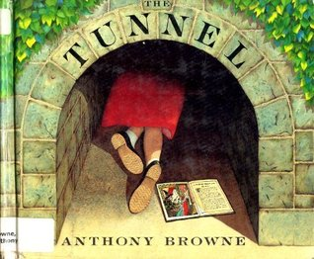

Read, Write, Inc
Skills | Objectives  (Word Reading) | What should be seen in the classroom?
Phonics and decoding | To use phonic knowledge to check whether a word makes sense in my reading.  To blend sounds in words that contain the graphemes learned.  To recognise and read alternative sounds for graphemes.  To read accurately words of two or more syllables containing these graphemes. | - Phonics teaching in differentiated groups, using Read, Write, Inc that is pitched at pupils’ reading ability not age.  -Daily high frequency words  -Weekly changed individual reading with books appropriate to the reading age of the child after benchmarking which include targeted sounds they are developing and can recognise. Additional book to promote these sounds is also included.  -Weekly changed ‘choosey book’ to encourage reading for pleasure  -Storytelling, songs and rhymes  - Word Walls recording key vocabulary that has been clarified and needs to ‘stick’  -Hear questions being asked to children throughout reading both whole class and individual.
Common Exception Words/ HFW | To read common exception words, noting unusual correspondences.
Fluency | To read most suitable books (closely matched to their improving phonic knowledge), sounding out unfamiliar words accurately, automatically and without hesitation.  To reread these books fluently and with confidence.
Skills | Objectives | What should be seen in the classroom?
Understanding and correcting inaccuracies | To use prior knowledge, including context and vocabulary and vocabulary provided by the teacher to understand texts. | -Daily individual reading  -Daily story time  -Reading Mastery techniques taught as a whole class at least twice weekly using sentence stems  -Think Aloud approach – ‘It makes me think that…’ ‘When I look at this image, I see…’ ‘When I read that sentence/word, I imagine…’  - Working Walls recording key discussion points and sentence stems  -Use of Bug Club
Connecting and becoming familiar with texts | To become increasingly familiar with and retell a wider range of stories, fairy stories and traditional tales (two targets split).  To recognise simple recurring literary language in stories and poems.
Non Fiction | To be introduced to and identify features of non-fiction books that are structured in different ways.
Poetry and Performance | To continue to build up a repertoire of poems learnt by heart, appreciating these and reciting some, with appropriate intonation to make the meaning clear.
Skills  (focused task in books) | Comprehension (VIPERS)  (One objective task in books per week as a minimum but all GR lessons will apply a range of skills) | Question Stems  (Task examples for books)
Week 1  Vocabulary | To discuss and clarify the meanings of words, linking new meanings to known vocabulary | • What does the word……….mean in this sentence?  • Find and copy a word which means ……….  • What does this word or phrase tell you about ………?  • Which word in this section do you think is the most important? Why?  • Which of the words best describes the character/setting/mood etc?  • Can you think of any other words the author could have used to describe this?  • Why do you think……….is repeated in this section?
Week 2  Inference | To draw (simple) inferences on the basis of what is being said and done. | •Why was…….feeling……..?  • Why did …………happen?  • Why did………. say……….?  • Can you explain why……….?  • What do you think the author intended when they said……….?  • How does……….make you feel?
Week 3 Prediction | To predict what might happen on the basis of what has been read so far. | • Look at the book cover/blurb –what do you think this book will be about?  • What do you think will happen next? What makes you think this?  • How does the choice of character or setting affect what will happen next?  • What is happening? What do you think happened before? What do you think will happen after?  • What do you think the last paragraph suggests? What will happen next?
Week 4  Explanation | To explain and discuss their understanding of books, poems and other material, both those that they listen to and those that they read for themselves. | • Who is your favourite character? Why?  • Why do you think all the main characters are girls in this book?  • Would you like to live in this setting? Why/why not?  • Is there anything you would change about this story?  • Do you like this text? What do you like about it?
Week 5  Retrieval | To ask and answer retrieval questions. | • What kind of text is this?  • Who did…..?  • Where did…..?  • When did…..?  • What happened when…..?  • Why did …….. happen?  • How did…….?  • How many…..?  • What happened to……?
Week 6  Sequence | To discuss the sequence of events in books and how items of information are related. | • Can you number these events 1-5 in the order that they happened?  • What happened after …….?  • What was the first thing that happened in the story?  • Can you summarise in a sentence the opening/middle/end of the story?  • In what order do these chapter headings come in the story?  •Sequence the key events in the story
Autumn 2 – Traction Man (Mini Grey)
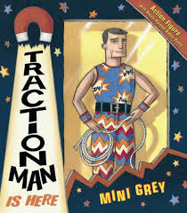

Read, Write, Inc

Skills | Objectives  (Word Reading) | What should be seen in the classroom?
Phonics and decoding | To use phonic knowledge to check whether a word makes sense in my reading.  To blend sounds in words that contain the graphemes learned.  To recognise and read alternative sounds for graphemes.  To read accurately words of two or more syllables containing these graphemes. | - Phonics teaching in differentiated groups, using Read, Write, Inc that is pitched at pupils’ reading ability not age.  -Daily high frequency words  -Weekly changed individual reading with books appropriate to the reading age of the child after benchmarking which include targeted sounds they are developing and can recognise. Additional book to promote these sounds is also included.  -Weekly changed ‘choosey book’ to encourage reading for pleasure  -Storytelling, songs and rhymes  - Word Walls recording key vocabulary that has been clarified and needs to ‘stick’  -Hear questions being asked to children throughout reading both whole class and individual.
Common Exception Words/ HFW | To read common exception words, noting unusual correspondences.
Fluency | To read most suitable books (closely matched to their improving phonic knowledge), sounding out unfamiliar words accurately, automatically and without hesitation.  To reread these books fluently and with confidence.
Skills | Objectives | What should be seen in the classroom?
Understanding and correcting inaccuracies | To use prior knowledge, including context and vocabulary and vocabulary provided by the teacher to understand texts. | -Daily individual reading  -Daily story time  -Reading Mastery techniques taught as a whole class at least twice weekly using sentence stems  -Think Aloud approach – ‘It makes me think that…’ ‘When I look at this image, I see…’ ‘When I read that sentence/word, I imagine…’  - Working Walls recording key discussion points and sentence stems  -Use of Bug Club
Connecting and becoming familiar with texts | To become increasingly familiar with and retell a wider range of stories, fairy stories and traditional tales (two targets split).  To recognise simple recurring literary language in stories and poems.
Non Fiction | To be introduced to and identify features of non-fiction books that are structured in different ways.
Poetry and Performance | To continue to build up a repertoire of poems learnt by heart, appreciating these and reciting some, with appropriate intonation to make the meaning clear.
Skills  (focused task in books) | Comprehension (VIPERS) | Question Stems
Week 1  Vocabulary | To discuss and clarify the meanings of words, linking new meanings to known vocabulary | • What does the word……….mean in this sentence?  • Find and copy a word which means ……….  • What does this word or phrase tell you about ………?  • Which word in this section do you think is the most important? Why?  • Which of the words best describes the character/setting/mood etc?  • Can you think of any other words the author could have used to describe this?  • Why do you think……….is repeated in this section?
Week 2  Inference | To draw (simple) inferences on the basis of what is being said and done. | •Why was…….feeling……..?  • Why did …………happen?  • Why did………. say……….?  • Can you explain why……….?  • What do you think the author intended when they said……….?  • How does……….make you feel?
Week 3 Prediction | To predict what might happen on the basis of what has been read so far. | • Look at the book cover/blurb –what do you think this book will be about?  • What do you think will happen next? What makes you think this?  • How does the choice of character or setting affect what will happen next?  • What is happening? What do you think happened before? What do you think will happen after?  • What do you think the last paragraph suggests? What will happen next?
Week 4  Explanation | To explain and discuss their understanding of books, poems and other material, both those that they listen to and those that they read for themselves. | • Who is your favourite character? Why?  • Why do you think all the main characters are girls in this book?  • Would you like to live in this setting? Why/why not?  • Is there anything you would change about this story?  • Do you like this text? What do you like about it?
Week 5  Retrieval | To ask and answer retrieval questions. | • What kind of text is this?  • Who did…..?  • Where did…..?  • When did…..?  • What happened when…..?  • Why did …….. happen?  • How did…….?  • How many…..?  • What happened to……?
Week 6  Sequence | To discuss the sequence of events in books and how items of information are related. | • Can you number these events 1-5 in the order that they happened?  • What happened after …….?  • What was the first thing that happened in the story?  • Can you summarise in a sentence the opening/middle/end of the story?  • In what order do these chapter headings come in the story?  •Sequence the key events in the story
Year 2
Spring 1 – Little Evie in the Wild Wood (Jackie Morris)
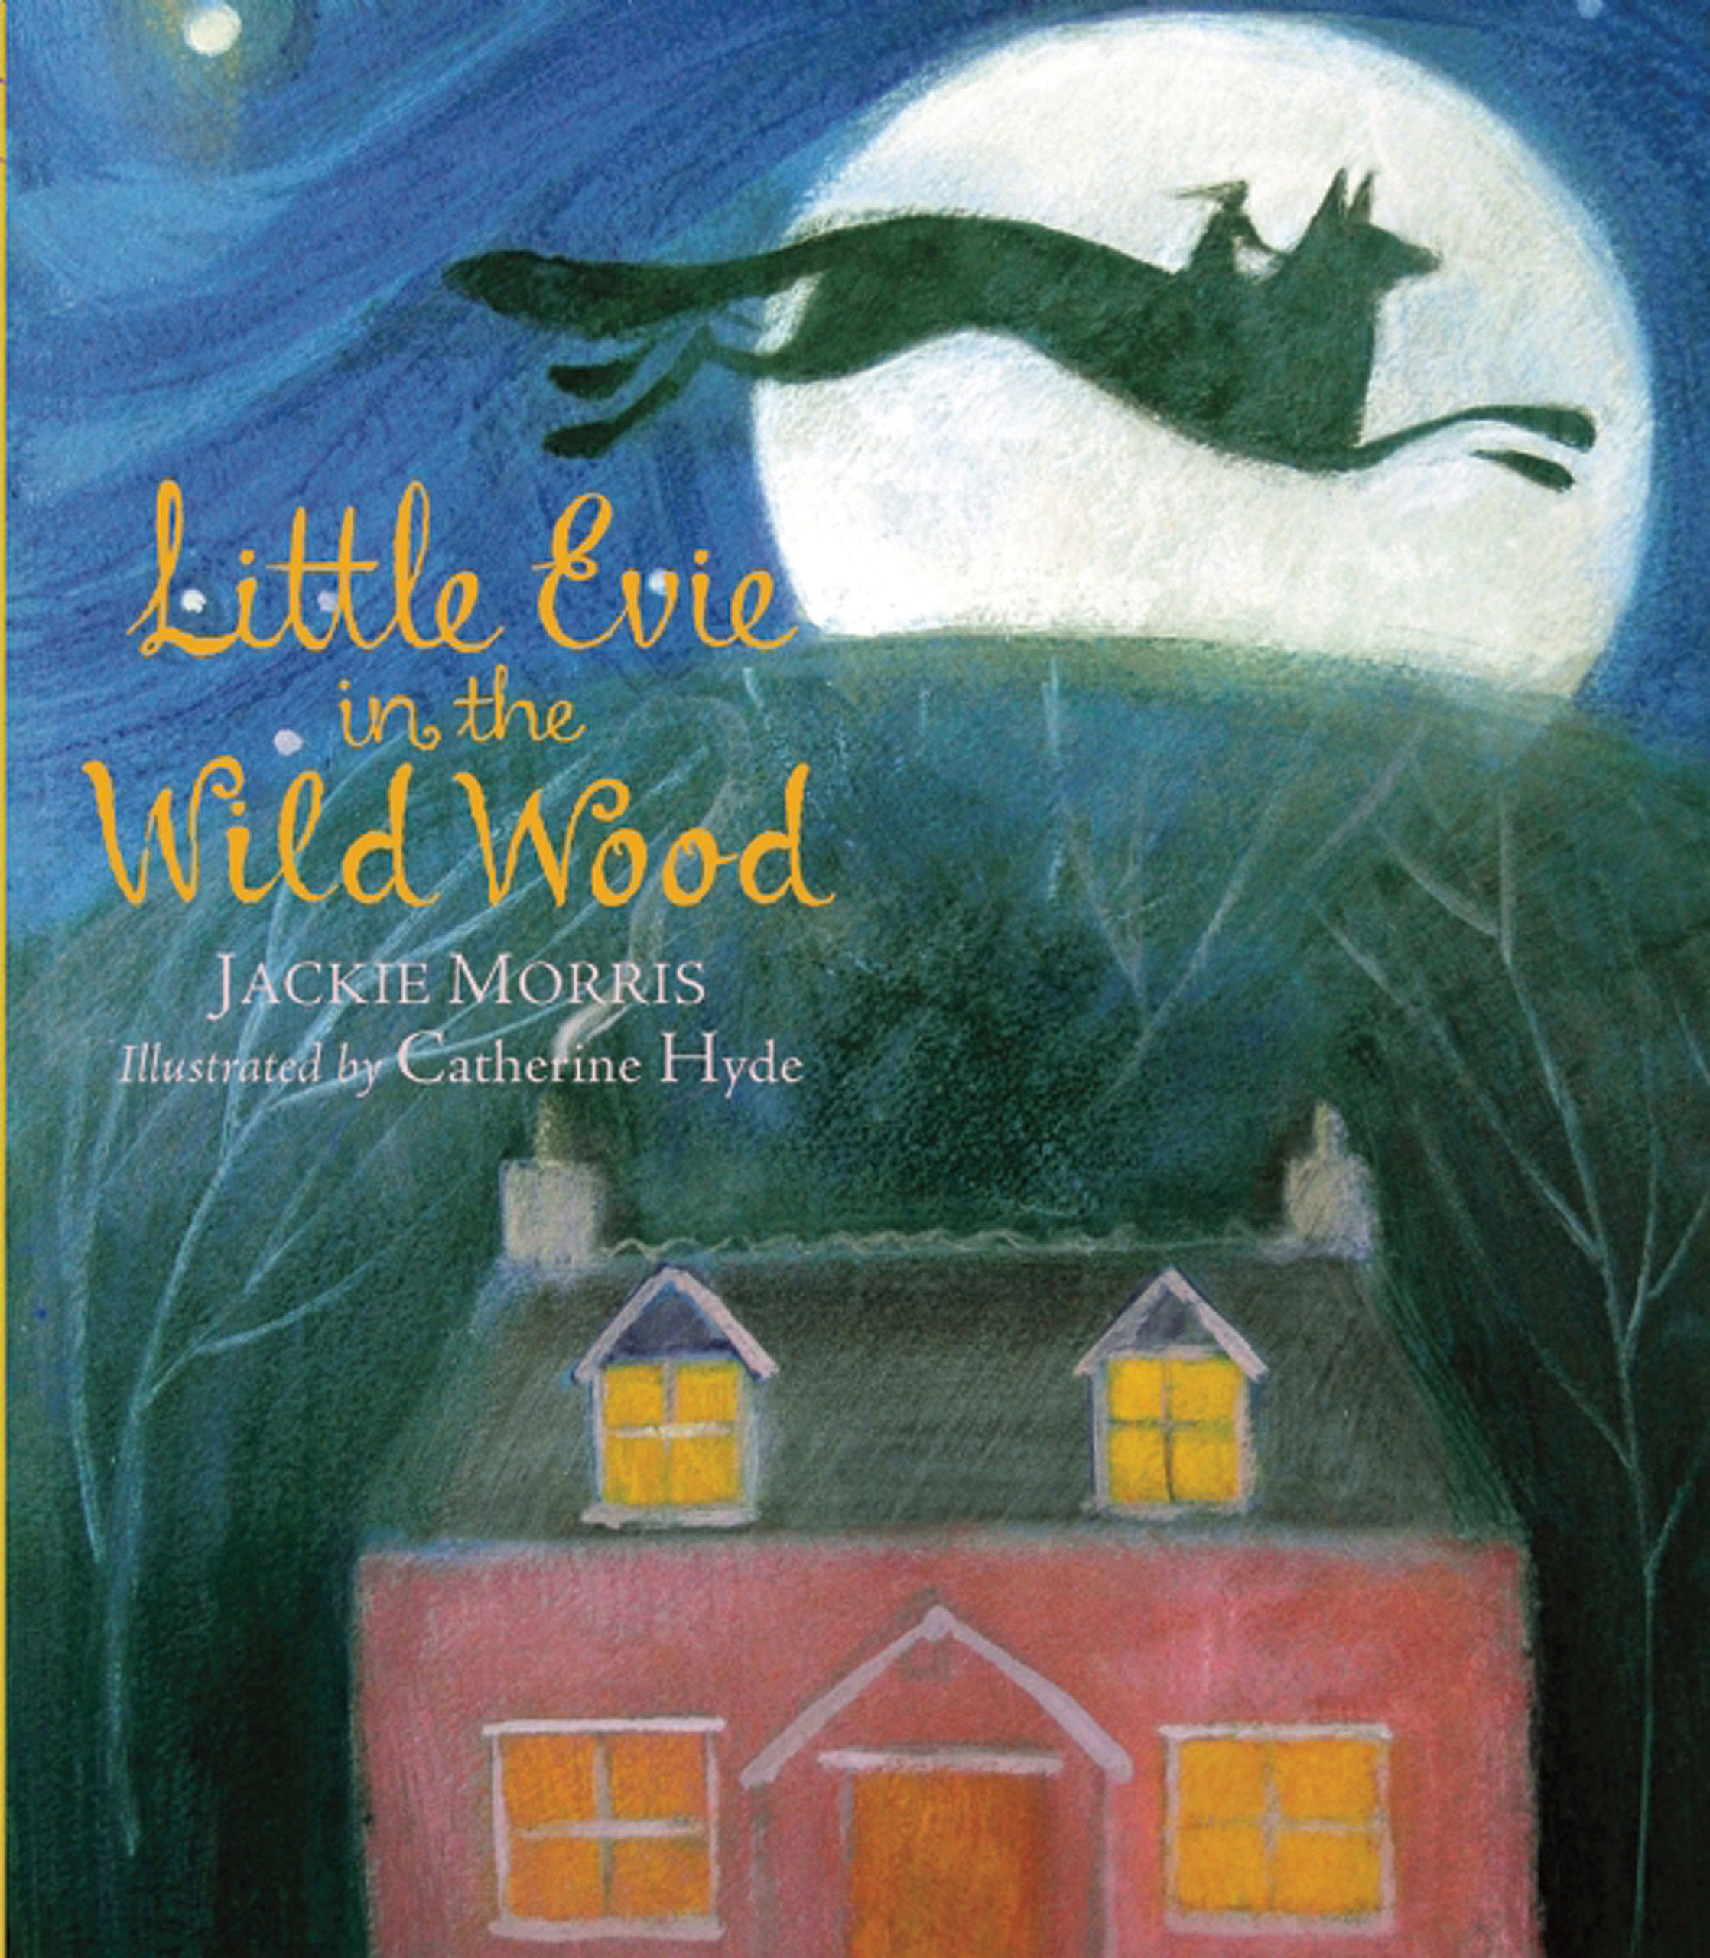

Read, Write, Inc

Skills | Objectives  (Word Reading) | What should be seen in the classroom?
Phonics and decoding | To use phonic knowledge to check whether a word makes sense in my reading.  To blend sounds in words that contain the graphemes learned.  To recognise and read alternative sounds for graphemes.  To read accurately words of two or more syllables containing these graphemes.  To read the root word when reading words with a suffix.  To read a word with a common suffix i.e. –ment, -ness, -ful, -less, -ly.  To identify differences between how a word is spelled and how it sounds.  To read most words quickly and accurately without overt sounding and blending. | - Phonics teaching in differentiated groups, using Read, Write, Inc that is pitched at pupils’ reading ability not age.  -Daily high frequency words  -Weekly changed individual reading with books appropriate to the reading age of the child after benchmarking which include targeted sounds they are developing and can recognise. Additional book to promote these sounds is also included.  -Weekly changed ‘choosey book’ to encourage reading for pleasure  -Storytelling, songs and rhymes  - Word Walls recording key vocabulary that has been clarified and needs to ‘stick’  - Hear questions being asked to children throughout reading both whole class and individual.
Common Exception Words/ HFW | To read common exception words, noting unusual correspondences.
Fluency | To read most suitable books (closely matched to their improving phonic knowledge), sounding out unfamiliar words accurately, automatically and without hesitation.  To reread these books fluently and with confidence.
Skills | Objectives | What should be seen in the classroom?
Understanding and correcting inaccuracies | To use prior knowledge, including context and vocabulary and vocabulary provided by the teacher to understand texts.  To check that the text makes sense as they read and to correct inaccurate reading. | -Daily individual reading  -Daily story time  -Reading Mastery techniques taught as a whole class at least twice weekly using sentence stems  -Think Aloud approach – ‘It makes me think that…’ ‘When I look at this image, I see…’ ‘When I read that sentence/word, I imagine…’  - Working Walls recording key discussion points and sentence stems  -Use of Bug Club
Connecting and becoming familiar with texts | To become increasingly familiar with and retell a wider range of stories, fairy stories and traditional tales (two targets split).  To recognise simple recurring literary language in stories and poems.  To talk about and give an opinion on a range of books, poems and other works that are read to them and those that they can read for themselves.  To answer and ask questions about the text, taking turns and listening to what others say.
Non Fiction | To be introduced to and identify features of non-fiction books that are structured in different ways.
Poetry and Performance | To continue to build up a repertoire of poems learnt by heart, appreciating these and reciting some, with appropriate intonation to make the meaning clear.
Skills  (focused task in books) | Comprehension (VIPERS) | Question Stems
Week 1  Vocabulary | To discuss and clarify the meanings of words, linking new meanings to known vocabulary  To discussing their favourite words and phrases in stories and poems. | • What does the word……….mean in this sentence?  • Find and copy a word which means ……….  • What does this word or phrase tell you about ………?  • Which word in this section do you think is the most important? Why?  • Which of the words best describes the character/setting/mood etc?  • Can you think of any other words the author could have used to describe this?  • Why do you think……….is repeated in this section?
Week 2  Inference | To draw (simple) inferences on the basis of what is being said and done.  To answer and ask questions about the text, taking turns and listening to what others say. | •Why was…….feeling……..?  • Why did …………happen?  • Why did………. say……….?  • Can you explain why……….?  • What do you think the author intended when they said……….?  • How does……….make you feel?
Week 3 Prediction | To predict what might happen on the basis of what has been read so far. | • Look at the book cover/blurb –what do you think this book will be about?  • What do you think will happen next? What makes you think this?  • How does the choice of character or setting affect what will happen next?  • What is happening? What do you think happened before? What do you think will happen after?  • What do you think the last paragraph suggests? What will happen next?
Week 4  Explanation | To explain and discuss their understanding of books, poems and other material, both those that they listen to and those that they read for themselves. | • Who is your favourite character? Why?  • Why do you think all the main characters are girls in this book?  • Would you like to live in this setting? Why/why not?  • Is there anything you would change about this story?  • Do you like this text? What do you like about it?
Week 5  Retrieval | To ask and answer retrieval questions. | • What kind of text is this?  • Who did…..?  • Where did…..?  • When did…..?  • What happened when…..?  • Why did …….. happen?  • How did…….?  • How many…..?  • What happened to……?
Week 6  Sequence | To discuss the sequence of events in books and how items of information are related. | • Can you number these events 1-5 in the order that they happened?  • What happened after …….?  • What was the first thing that happened in the story?  • Can you summarise in a sentence the opening/middle/end of the story?  • In what order do these chapter headings come in the story?  •Sequence the key events in the story
Year 2
Spring 2 – Lila and the Secret of Rain
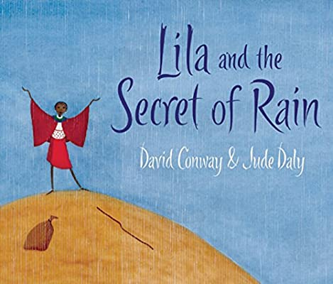

Read, Write, Inc

Skills | Objectives  (Word Reading) | What should be seen in the classroom?
Phonics and decoding | To use phonic knowledge to check whether a word makes sense in my reading.  To blend sounds in words that contain the graphemes learned.  To recognise and read alternative sounds for graphemes.  To read accurately words of two or more syllables containing these graphemes.  To read the root word when reading words with a suffix.  To read a word with a common suffix i.e. –ment, -ness, -ful, -less, -ly.  To identify differences between how a word is spelled and how it sounds.  To read most words quickly and accurately without overt sounding and blending. | - Phonics teaching in differentiated groups, using Read, Write, Inc that is pitched at pupils’ reading ability not age.  -Daily high frequency words  -Weekly changed individual reading with books appropriate to the reading age of the child after benchmarking which include targeted sounds they are developing and can recognise. Additional book to promote these sounds is also included.  -Weekly changed ‘choosey book’ to encourage reading for pleasure  -Storytelling, songs and rhymes  - Word Walls recording key vocabulary that has been clarified and needs to ‘stick’  -Hear questions being asked to children throughout reading both whole class and individual.
Common Exception Words/ HFW | To read common exception words, noting unusual correspondences.
Fluency | To read most suitable books (closely matched to their improving phonic knowledge), sounding out unfamiliar words accurately, automatically and without hesitation.  To reread these books fluently and with confidence.
Skills | Objectives | What should be seen in the classroom?
Understanding and correcting inaccuracies | To use prior knowledge, including context and vocabulary and vocabulary provided by the teacher to understand texts.  To check that the text makes sense as they read and to correct inaccurate reading. | -Daily individual reading  -Daily story time  -Reading Mastery techniques taught as a whole class at least twice weekly using sentence stems  -Think Aloud approach – ‘It makes me think that…’ ‘When I look at this image, I see…’ ‘When I read that sentence/word, I imagine…’  - Working Walls recording key discussion points and sentence stems  -Use of Bug Club
Connecting and becoming familiar with texts | To become increasingly familiar with and retell a wider range of stories, fairy stories and traditional tales (two targets split).  To recognise simple recurring literary language in stories and poems.  To talk about and give an opinion on a range of books, poems and other works that are read to them and those that they can read for themselves.  To answer and ask questions about the text, taking turns and listening to what others say.
Non Fiction | To be introduced to and identify features of non-fiction books that are structured in different ways.
Poetry and Performance | To continue to build up a repertoire of poems learnt by heart, appreciating these and reciting some, with appropriate intonation to make the meaning clear.
Skills  (focused task in books) | Comprehension (VIPERS) | Question Stems
Week 1  Vocabulary | To discuss and clarify the meanings of words, linking new meanings to known vocabulary  To discussing their favourite words and phrases in stories and poems. | • What does the word……….mean in this sentence?  • Find and copy a word which means ……….  • What does this word or phrase tell you about ………?  • Which word in this section do you think is the most important? Why?  • Which of the words best describes the character/setting/mood etc?  • Can you think of any other words the author could have used to describe this?  • Why do you think……….is repeated in this section?
Week 2  Inference | To draw (simple) inferences on the basis of what is being said and done.  To answer and ask questions about the text, taking turns and listening to what others say. | •Why was…….feeling……..?  • Why did …………happen?  • Why did………. say……….?  • Can you explain why……….?  • What do you think the author intended when they said……….?  • How does……….make you feel?
Week 3 Prediction | To predict what might happen on the basis of what has been read so far. | • Look at the book cover/blurb –what do you think this book will be about?  • What do you think will happen next? What makes you think this?  • How does the choice of character or setting affect what will happen next?  • What is happening? What do you think happened before? What do you think will happen after?  • What do you think the last paragraph suggests? What will happen next?
Week 4  Explanation | To explain and discuss their understanding of books, poems and other material, both those that they listen to and those that they read for themselves. | • Who is your favourite character? Why?  • Why do you think all the main characters are girls in this book?  • Would you like to live in this setting? Why/why not?  • Is there anything you would change about this story?  • Do you like this text? What do you like about it?
Week 5  Retrieval | To ask and answer retrieval questions. | • What kind of text is this?  • Who did…..?  • Where did…..?  • When did…..?  • What happened when…..?  • Why did …….. happen?  • How did…….?  • How many…..?  • What happened to……?
Week 6  Sequence | To discuss the sequence of events in books and how items of information are related. | • Can you number these events 1-5 in the order that they happened?  • What happened after …….?  • What was the first thing that happened in the story?  • Can you summarise in a sentence the opening/middle/end of the story?  • In what order do these chapter headings come in the story?  •Sequence the key events in the story
Year 2
Summer 1 – The Man on the Moon (Simon Bartram)
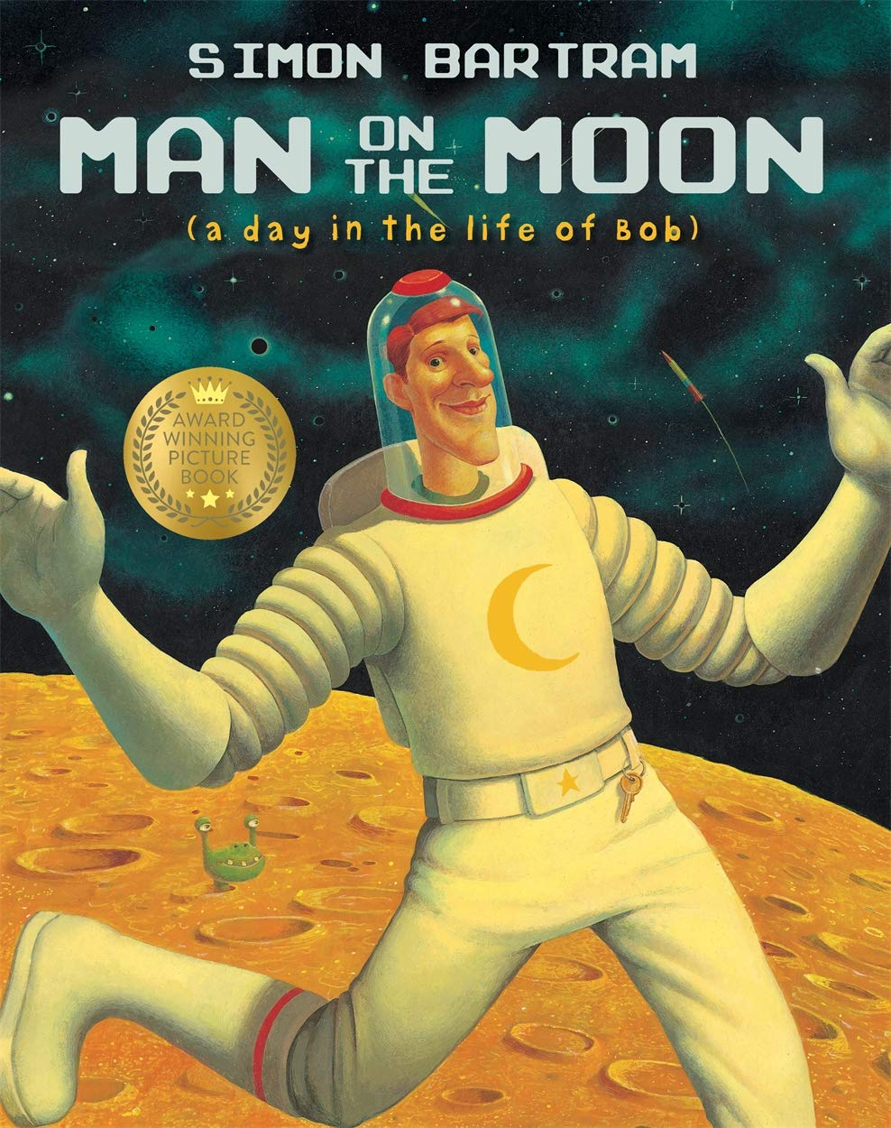

Read, Write, Inc

Skills | Objectives  (Word Reading) | What should be seen in the classroom?
Phonics and decoding | To use phonic knowledge to check whether a word makes sense in my reading.  To blend sounds in words that contain the graphemes learned.  To recognise and read alternative sounds for graphemes.  To read accurately words of two or more syllables containing these graphemes.  To read the root word when reading words with a suffix.  To read a word with a common suffix i.e. –ment, -ness, -ful, -less, -ly.  To identify differences between how a word is spelled and how it sounds.  To read most words quickly and accurately without overt sounding and blending. | - Phonics teaching in differentiated groups, using Read, Write, Inc that is pitched at pupils’ reading ability not age.  -Daily high frequency words  -Weekly changed individual reading with books appropriate to the reading age of the child after benchmarking which include targeted sounds they are developing and can recognise. Additional book to promote these sounds is also included.  -Weekly changed ‘choosey book’ to encourage reading for pleasure  -Storytelling, songs and rhymes  - Word Walls recording key vocabulary that has been clarified and needs to ‘stick’  -Hear questions being asked to children throughout reading both whole class and individual.
Common Exception Words/ HFW | To read common exception words, noting unusual correspondences.
Fluency | To read most suitable books (closely matched to their improving phonic knowledge), sounding out unfamiliar words accurately, automatically and without hesitation.  To reread these books fluently and with confidence.
Skills | Objectives | What should be seen in the classroom?
Understanding and correcting inaccuracies | To use prior knowledge, including context and vocabulary and vocabulary provided by the teacher to understand texts.  To check that the text makes sense as they read and to correct inaccurate reading. | -Daily individual reading  -Daily story time  -Reading Mastery techniques taught as a whole class at least twice weekly using sentence stems  -Think Aloud approach – ‘It makes me think that…’ ‘When I look at this image, I see…’ ‘When I read that sentence/word, I imagine…’  - Working Walls recording key discussion points and sentence stems  -Use of Bug Club
Connecting and becoming familiar with texts | To become increasingly familiar with and retell a wider range of stories, fairy stories and traditional tales (two targets split).  To recognise simple recurring literary language in stories and poems.  To talk about and give an opinion on a range of books, poems and other works that are read to them and those that they can read for themselves.  To answer and ask questions about the text, taking turns and listening to what others say.
Non Fiction | To be introduced to and identify features of non-fiction books that are structured in different ways.
Poetry and Performance | To continue to build up a repertoire of poems learnt by heart, appreciating these and reciting some, with appropriate intonation to make the meaning clear.
Skills  (focused task in books) | Comprehension (VIPERS) | Question Stems
Week 1  Vocabulary | To discuss and clarify the meanings of words, linking new meanings to known vocabulary  To discussing their favourite words and phrases in stories and poems. | • What does the word……….mean in this sentence?  • Find and copy a word which means ……….  • What does this word or phrase tell you about ………?  • Which word in this section do you think is the most important? Why?  • Which of the words best describes the character/setting/mood etc?  • Can you think of any other words the author could have used to describe this?  • Why do you think……….is repeated in this section?
Week 2  Inference | To draw (simple) inferences on the basis of what is being said and done.  To answer and ask questions about the text, taking turns and listening to what others say. | •Why was…….feeling……..?  • Why did …………happen?  • Why did………. say……….?  • Can you explain why……….?  • What do you think the author intended when they said……….?  • How does……….make you feel?
Week 3 Prediction | To predict what might happen on the basis of what has been read so far. | • Look at the book cover/blurb –what do you think this book will be about?  • What do you think will happen next? What makes you think this?  • How does the choice of character or setting affect what will happen next?  • What is happening? What do you think happened before? What do you think will happen after?  • What do you think the last paragraph suggests? What will happen next?
Week 4  Explanation | To explain and discuss their understanding of books, poems and other material, both those that they listen to and those that they read for themselves. | • Who is your favourite character? Why?  • Why do you think all the main characters are girls in this book?  • Would you like to live in this setting? Why/why not?  • Is there anything you would change about this story?  • Do you like this text? What do you like about it?
Week 5  Retrieval | To ask and answer retrieval questions. | • What kind of text is this?  • Who did…..?  • Where did…..?  • When did…..?  • What happened when…..?  • Why did …….. happen?  • How did…….?  • How many…..?  • What happened to……?
Week 6  Sequence | To discuss the sequence of events in books and how items of information are related. | • Can you number these events 1-5 in the order that they happened?  • What happened after …….?  • What was the first thing that happened in the story?  • Can you summarise in a sentence the opening/middle/end of the story?  • In what order do these chapter headings come in the story?  •Sequence the key events in the story

Summer 2 – The Owl and the Pussycat (Edward Lear)
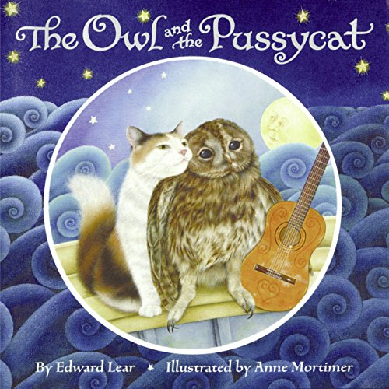

Read, Write, Inc

Skills | Objectives  (Word Reading) | What should be seen in the classroom?
Phonics and decoding | To use phonic knowledge to check whether a word makes sense in my reading.  To blend sounds in words that contain the graphemes learned.  To recognise and read alternative sounds for graphemes.  To read accurately words of two or more syllables containing these graphemes.  To read the root word when reading words with a suffix.  To read a word with a common suffix i.e. –ment, -ness, -ful, -less, -ly.  To identify differences between how a word is spelled and how it sounds.  To read most words quickly and accurately without overt sounding and blending. | - Phonics teaching in differentiated groups, using Read, Write, Inc that is pitched at pupils’ reading ability not age.  -Daily high frequency words  -Weekly changed individual reading with books appropriate to the reading age of the child after benchmarking which include targeted sounds they are developing and can recognise. Additional book to promote these sounds is also included.  -Weekly changed ‘choosey book’ to encourage reading for pleasure  -Storytelling, songs and rhymes  - Word Walls recording key vocabulary that has been clarified and needs to ‘stick’  -Hear questions being asked to children throughout reading both whole class and individual.
Common Exception Words/ HFW | To read common exception words, noting unusual correspondences.
Fluency | To read most suitable books (closely matched to their improving phonic knowledge), sounding out unfamiliar words accurately, automatically and without hesitation.  To reread these books fluently and with confidence.
Skills | Objectives | What should be seen in the classroom?
Understanding and correcting inaccuracies | To use prior knowledge, including context and vocabulary and vocabulary provided by the teacher to understand texts.  To check that the text makes sense as they read and to correct inaccurate reading. | -Daily individual reading  -Daily story time  -Reading Mastery techniques taught as a whole class at least twice weekly using sentence stems  -Think Aloud approach – ‘It makes me think that…’ ‘When I look at this image, I see…’ ‘When I read that sentence/word, I imagine…’  - Working Walls recording key discussion points and sentence stems  -Use of Bug Club
Connecting and becoming familiar with texts | To become increasingly familiar with and retell a wider range of stories, fairy stories and traditional tales (two targets split).  To recognise simple recurring literary language in stories and poems.  To talk about and give an opinion on a range of books, poems and other works that are read to them and those that they can read for themselves.  To answer and ask questions about the text, taking turns and listening to what others say.
Non Fiction | To be introduced to and identify features of non-fiction books that are structured in different ways.
Poetry and Performance | To continue to build up a repertoire of poems learnt by heart, appreciating these and reciting some, with appropriate intonation to make the meaning clear.
Skills  (focused task in books) | Comprehension (VIPERS) | Question Stems
Week 1  Vocabulary | To discuss and clarify the meanings of words, linking new meanings to known vocabulary  To discussing their favourite words and phrases in stories and poems. | • What does the word……….mean in this sentence?  • Find and copy a word which means ……….  • What does this word or phrase tell you about ………?  • Which word in this section do you think is the most important? Why?  • Which of the words best describes the character/setting/mood etc?  • Can you think of any other words the author could have used to describe this?  • Why do you think……….is repeated in this section?
Week 2  Inference | To draw (simple) inferences on the basis of what is being said and done.  To answer and ask questions about the text, taking turns and listening to what others say. | •Why was…….feeling……..?  • Why did …………happen?  • Why did………. say……….?  • Can you explain why……….?  • What do you think the author intended when they said……….?  • How does……….make you feel?
Week 3 Prediction | To predict what might happen on the basis of what has been read so far. | • Look at the book cover/blurb –what do you think this book will be about?  • What do you think will happen next? What makes you think this?  • How does the choice of character or setting affect what will happen next?  • What is happening? What do you think happened before? What do you think will happen after?  • What do you think the last paragraph suggests? What will happen next?
Week 4  Explanation | To explain and discuss their understanding of books, poems and other material, both those that they listen to and those that they read for themselves. | • Who is your favourite character? Why?  • Why do you think all the main characters are girls in this book?  • Would you like to live in this setting? Why/why not?  • Is there anything you would change about this story?  • Do you like this text? What do you like about it?
Week 5  Retrieval | To ask and answer retrieval questions. | • What kind of text is this?  • Who did…..?  • Where did…..?  • When did…..?  • What happened when…..?  • Why did …….. happen?  • How did…….?  • How many…..?  • What happened to……?
Week 6  Sequence | To discuss the sequence of events in books and how items of information are related. | • Can you number these events 1-5 in the order that they happened?  • What happened after …….?  • What was the first thing that happened in the story?  • Can you summarise in a sentence the opening/middle/end of the story?  • In what order do these chapter headings come in the story?  •Sequence the key events in the story

