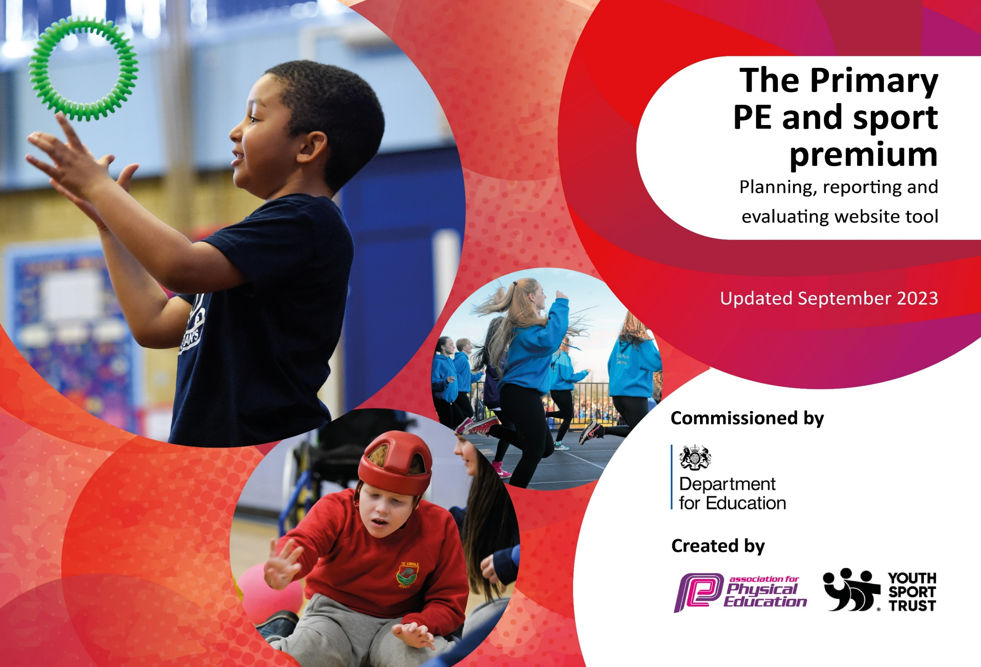

DfE: Schools should prioritise PE and sport premium spending to improve in the following 5 key (indicators) areas:
- increasing all staff’s confidence, knowledge and skills in teaching PE and sport
- increasing engagement of all pupils in regular physical activity and sport
- raising the profile of PE and sport across the school, to support whole school improvement
- offer a broader and more equal experience of a range of sports and physical activities to all pupils
- increase participation in competitive sport

Action – what are you planning to do | Who does this action impact? | Key indicator to meet | Impacts and how sustainability will be achieved? | Cost linked to the action
Introduce lunchtime sport sessions/activities for pupils. | Lunchtime supervisors, Tigers Trust coaches - as they need to lead the activity.  The pupils taking part. | Key indicator 2 -The engagement of all pupils in regular physical activity – the Chief Medical Officer guidelines recommend that all children and young people aged 5 to 18 engage in at least 60 minutes of physical activity per day, of which 30 minutes should be in school.  Key indicator 4: Broader experience of a range of sports and activities offered to all pupils. | More pupils meeting their daily physical activity goal, more pupils encouraged to take part in PE and Sport Activities. | Tigers Trust annual fee.  £9000  Budget playtime and lunch time equipment. £3000
Raise attainment in primary school swimming. | Year 5 and Year 6 children. | Key indicator 2 - The engagement of all pupils in regular physical activity.  Key indicator 4: Broader experience of a range of sports and activities offered to all pupils. | All children by the end of Key Stage 2 will be able to swim the statutory 25meters using a range of strokes effectively (front crawl, breast stroke, back stroke).  All children will have an understanding of water safety and safe self-rescue. | £2000 x 2 classes.
Increase confidence knowledge and skills in all staff in teaching PE and sport. | All teaching staff.  All children. | Key indicator 1: Increase confidence knowledge and skills in all staff in teaching PE and sport.  Key indicator 3: The profile of PE and sport is raised across the school as a tool for whole school improvement. | Children receive high quality consistent PE and sport teaching across the school.  Bespoke CPD training for 2 x ECTs in gymnastics (JP). (Autumn Term)  CPD will ensure sustainability and development of staff teaching.  - Tigers Trust  - Hull Active Schools  - School Games | Hull Active School /Tigers Trust who are providing the CPD.
Increase participation in competitive sport. | All children have the opportunity to complete a various competitive events including SEND/disadvantaged. | Key indicator 4: Broader experience of a range of sports and activities offered to all pupils.  Key indicator 5: Increased participation in competitive sport. | Focus will be on two areas, a competitive element and an inclusive/disadvantaged participation in sport.  All children have access to a range of PE and sport opportunities in both a competitive nature and to broaden their experiences in a range of sports. | Hull Active School annual cost £4000
Increase participation of girls in sport. | All girls across the school ensuring they have equal access to sports opportunities. | Key indicator 2: The engagement of all pupils in regular physical activity.  Key indicator 4: Broader experience of a range of sports and activities offered to all pupils.  Key indicator 5: Increased participation in competitive sport. | 100% more girls engage in PE and sport both for enjoyment and in a competitive nature compared to last year’s figures.
Complete PE Interactive PE resource subscription | To support teachers to feel confident delivering PE lessons by implementing Complete PE | - Key indicator 1: increasing all staff’s confidence, knowledge and skills in teaching PE and sport | PE observations and drop ins will demonstrates staff’s confidence to deliver PE lessons which are at least good in all year groups. | £1000
 |  |  | Total spends: | £21000

Review: July 2024
Key achievements 2023-2024
This template will be completed at the end of the academic year and will showcase the key achievements Parkstone Primary school have made with their Primary PE and sport premium spending.

Activity/Action | Impact | Comments

